MỤC LỤC

CHAPTER 1. INSTALL AND CONFIGURE UBUNTU 3

1.1 Purposes 3

1.2 Requirements 3

1.3 Practice 3

1.4 Questions 56

CHAPTER 2. PROCESSES AND THREADS 67

2.1 Purposes 67

2.2 Requirements 67

2.3 Practice and Questions 67

2.3.1 Practice 67

2.3.1 Questions 73

CHAPTER 3. DEADLOCKS 91

3.1 Purposes 91

3.2 Requirements 91

3.3 Practice and Questions 91

3.3.1 Practice 91

3.3.2 Questions 91

CHAPTER 4. MEMORY MANAGEMENT 103

4.1 Purposes 103

4.2 Requirements 103

4.3 Practice and Questions 103

4.3.1 Practice 103

4.3.2 Questions 103

CHAPTER 5. INPUT/OUTPUT 112

5.1 Purposes 112

5.2 Requirements 112

5.3 Practice and Questions 112

5.3.1 Practice 112

5.3.2 Questions 112

CHAPTER 6. FILE SYSTEMS 121

6.1 Purposes 121

6.2 Requirements 121

6.3 Practice and Questions 121

6.3.1 Practice 121

6.3.2 Questions 121

# CHAPTER 1. INSTALL AND CONFIGURE UBUNTU

## 1.1 Purposes

## 1.2 Requirements

## 1.3 Practice

1. Installing Vmware Workstation 15.x
   * Opening the folder that consists of Vmware workstationg 15.x

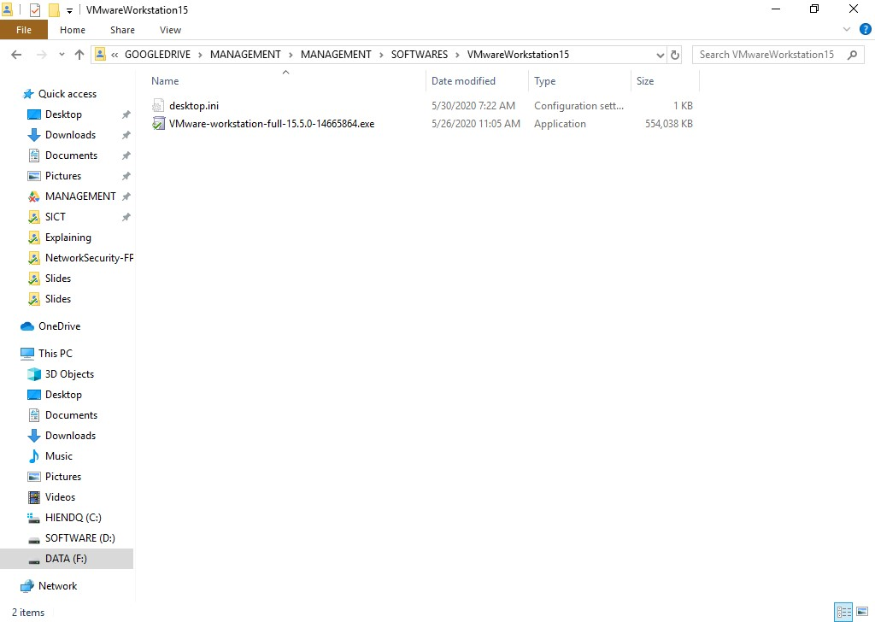

* + Double click to this file to install

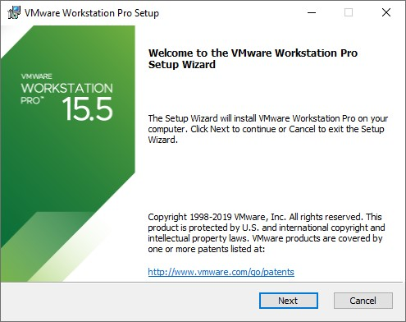

* + Click Next

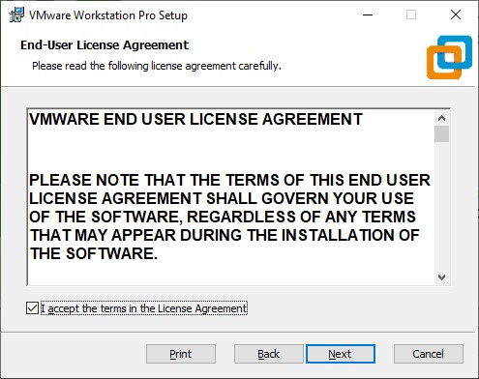

Click I accept the terms in the License Agreement. Click Next.

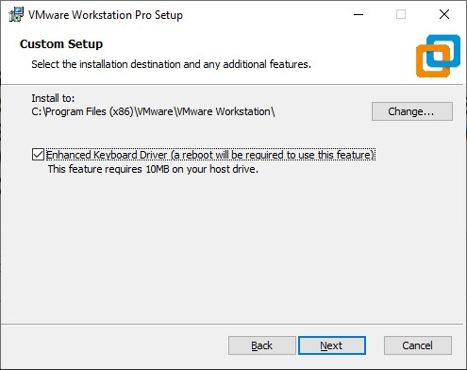

* + Click Next

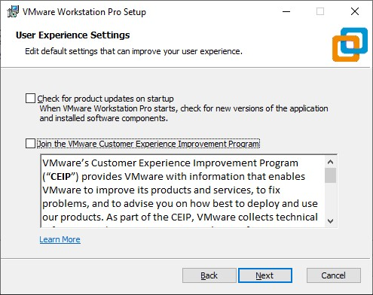

Click Next

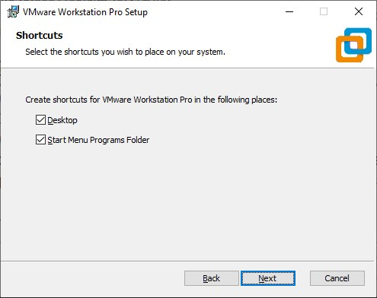

* + Checking Desktop and Start Menu Programs Folder. Then click Next.

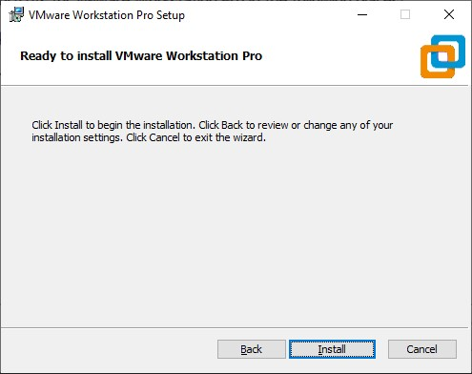

Click Install.

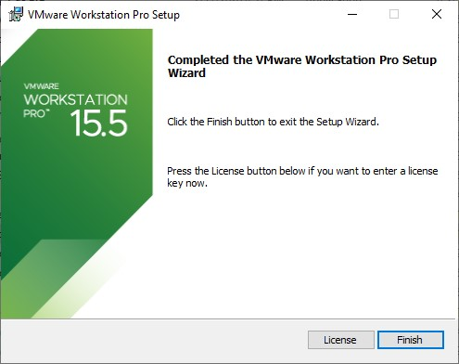

* + Click Finish to complete installing Vmware workstation 15.5.

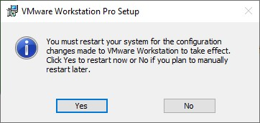

* + Click Yes to reestart your system.

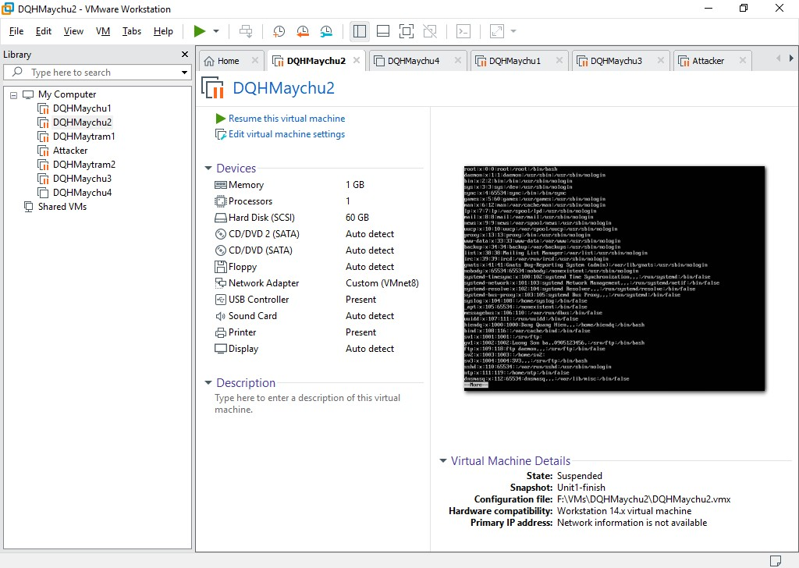

1. Installling and configuring Ubuntu desktop 20.04
   * Create a virtual machine for installing Ubuntu desktop 20.04. Press Ctrl + N.

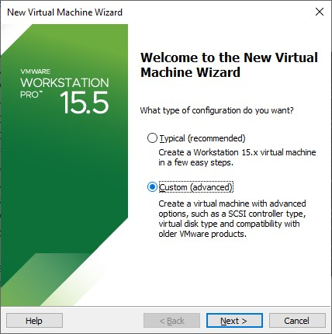

* + Click Custom (advanced). Click Next.

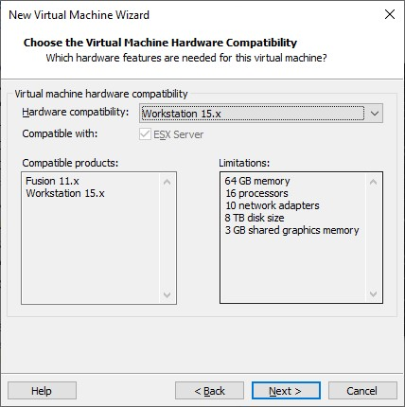

* + Click Next.

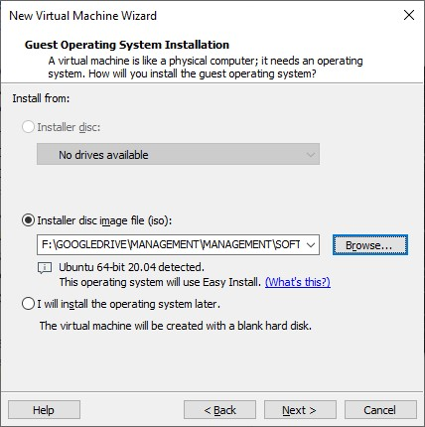

Click Browse… and choose the Ubuntu Desktop 20.04 iso file. Then click Next.

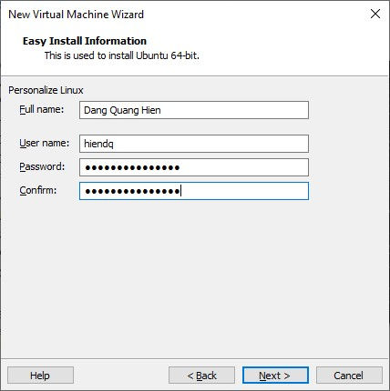

* + Providing necessary information for the first user on this system. Click Next.

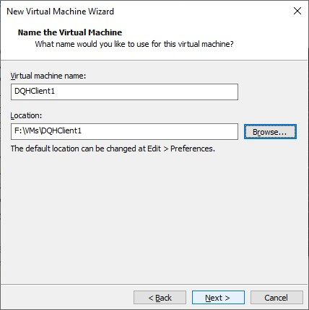

Naming this virtual machine and choose the location for this VM. Click Next.

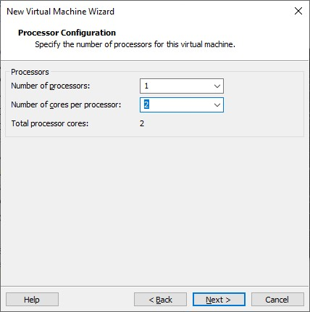

* + Choose number of cores per processor. Click Next.

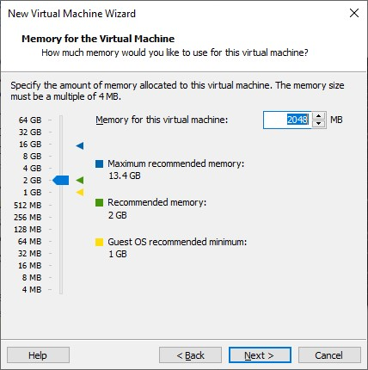

Specify the amount of RAM and then click Next.

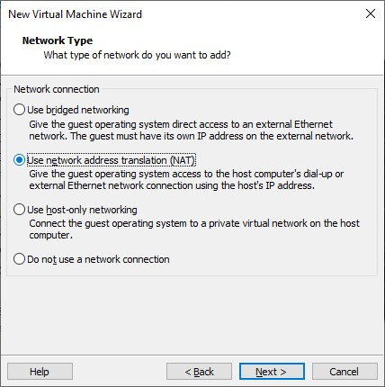

* + Choose network connection NAT for this virtual machine. Click Next.

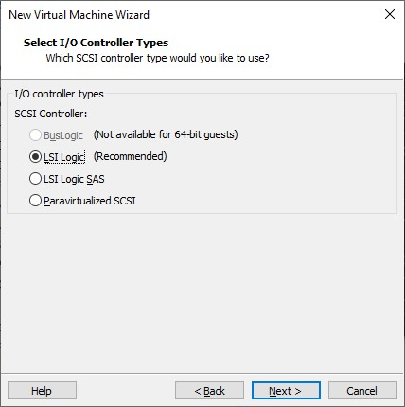

Choose LSI Logic and click Next.

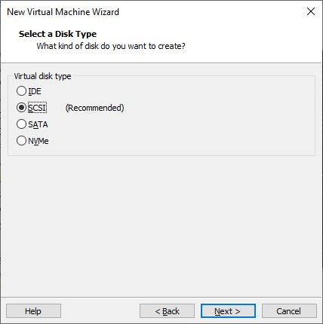

* + Select disk type SCSI as recommendation and then click Next.

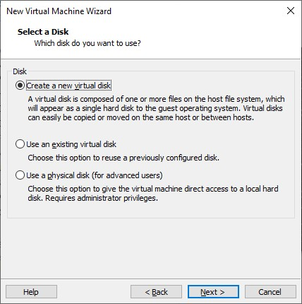

Clilck **Create a new virtual disk** to use files on real machine as virtual disk on virtual machine. Click Next.

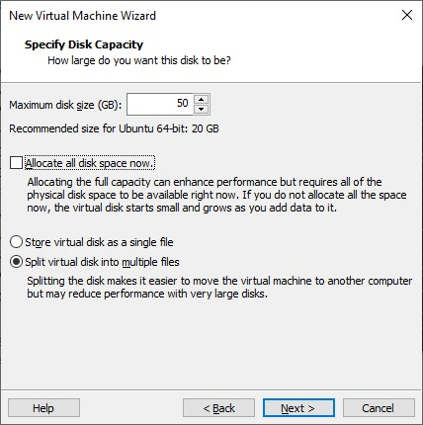

* + Specify disk capacity (about 50 GB). Click Next.

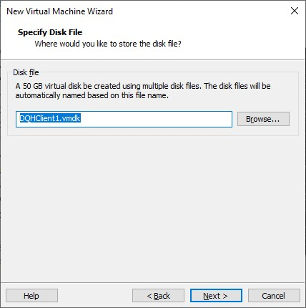

Click Next.

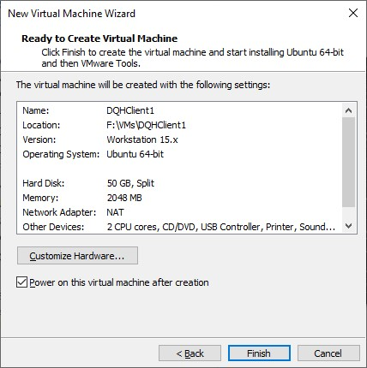

* + Click Customize Hardware… to adjust the configuration.

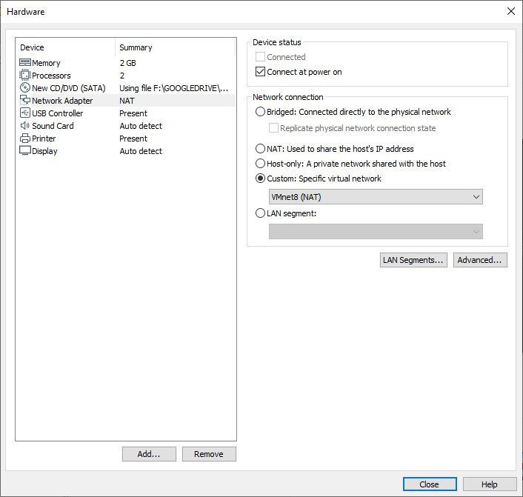

* + Choose Vmnet8 (NAT) for networking. Click Close.

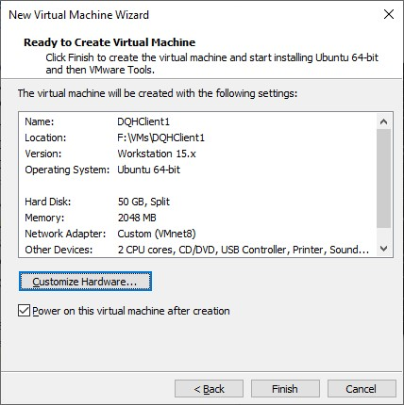

* + Click Finish to start installing Ubuntu desktop 20.04 on your virtual machine.

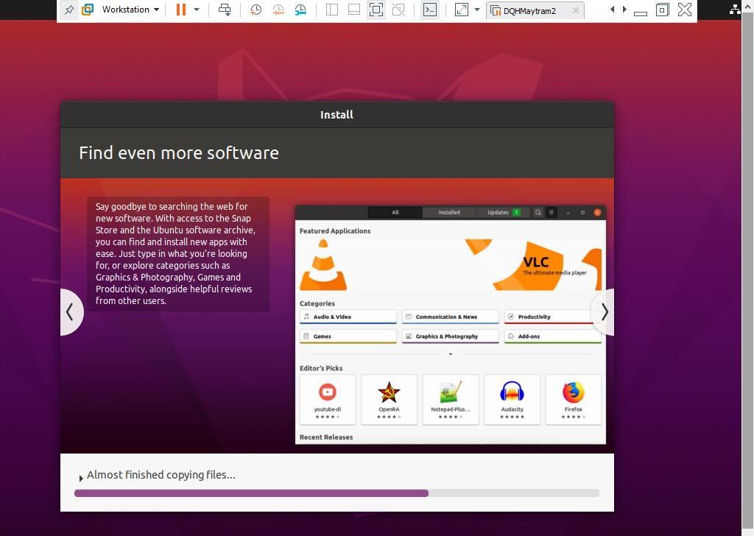

* + Waiting for this installation.

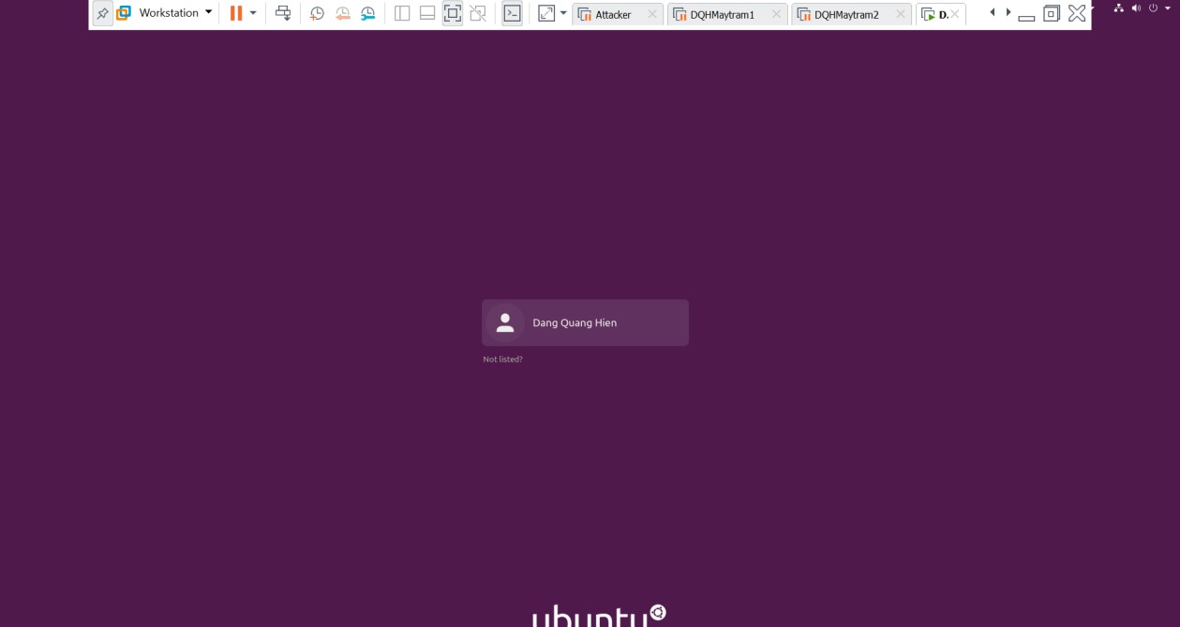

* + Click to the fullname on the screen and log in this system.

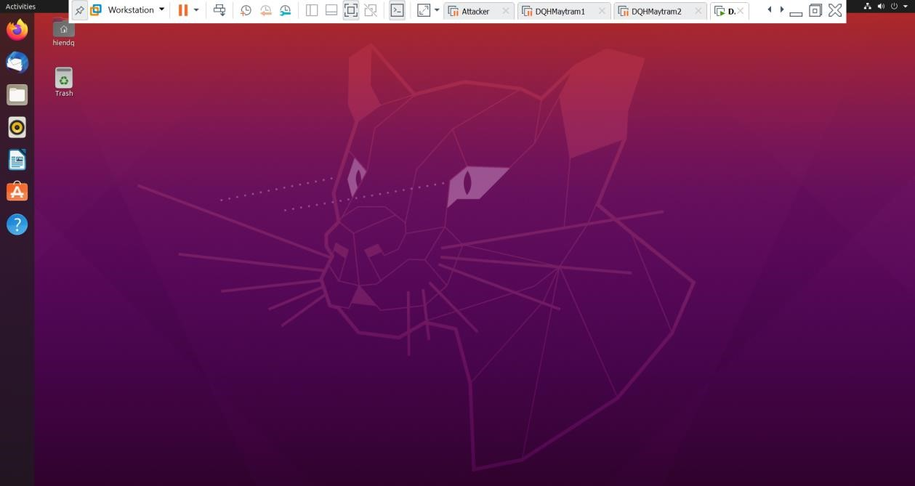

1. Setting root password:
   * Pressing , type “terminal”



* + Press Enter to open this program

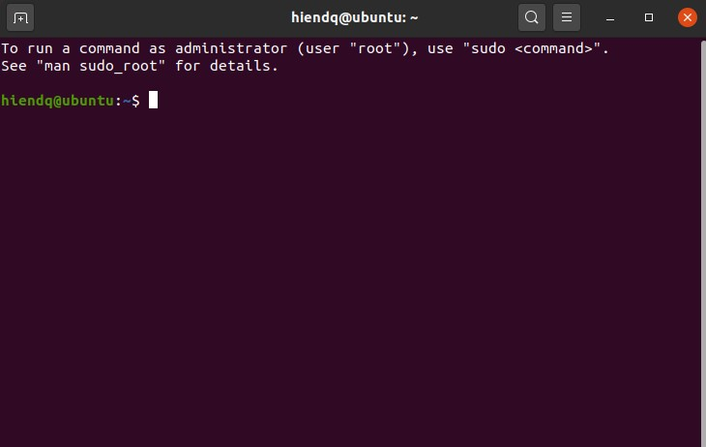

* + We are using the command *#sudo passwd root* to set password for the user root.

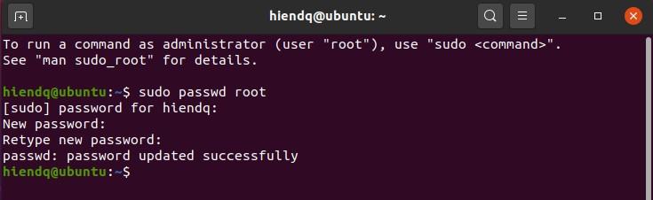

* + Now, we use the command *#su root* to switch from current user to superuser.

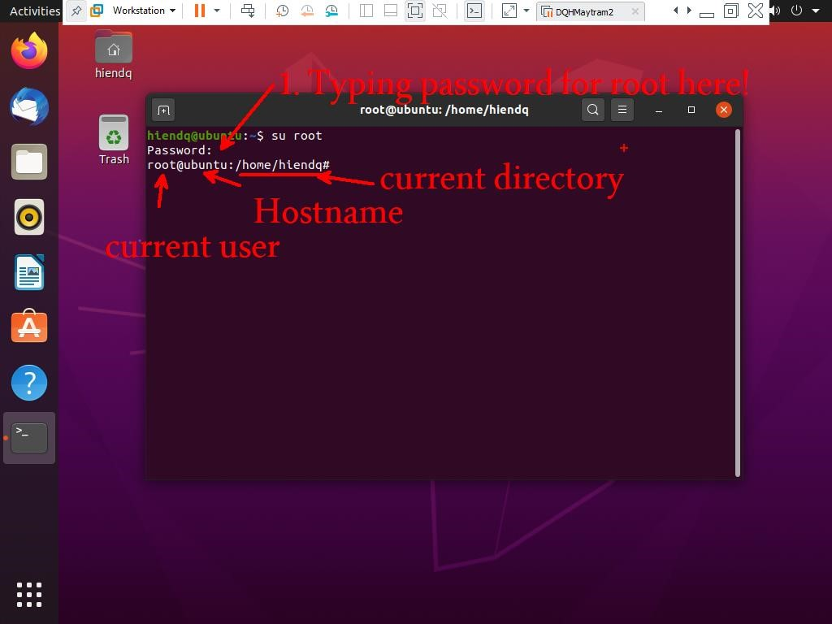

* + Using the command *#cd* to return homefolder of root.

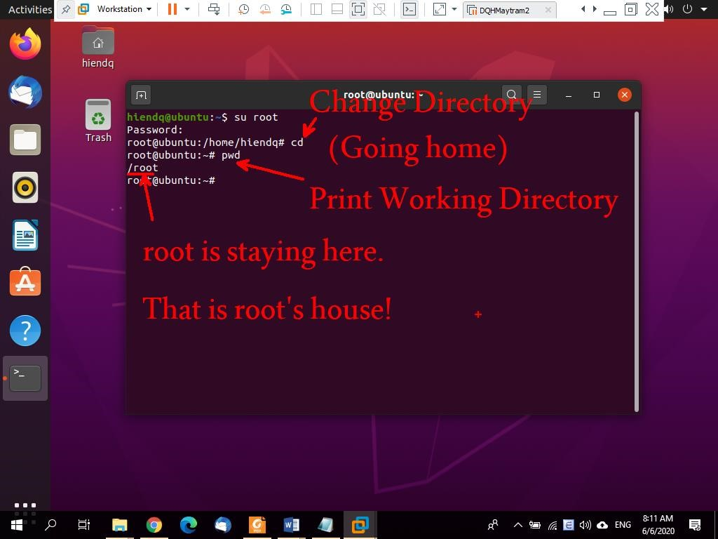

1. Hostname configuration:
   * Changing the default hostname to your student ID (for example: DE14027) by using the command *#nano /etc/hosts*

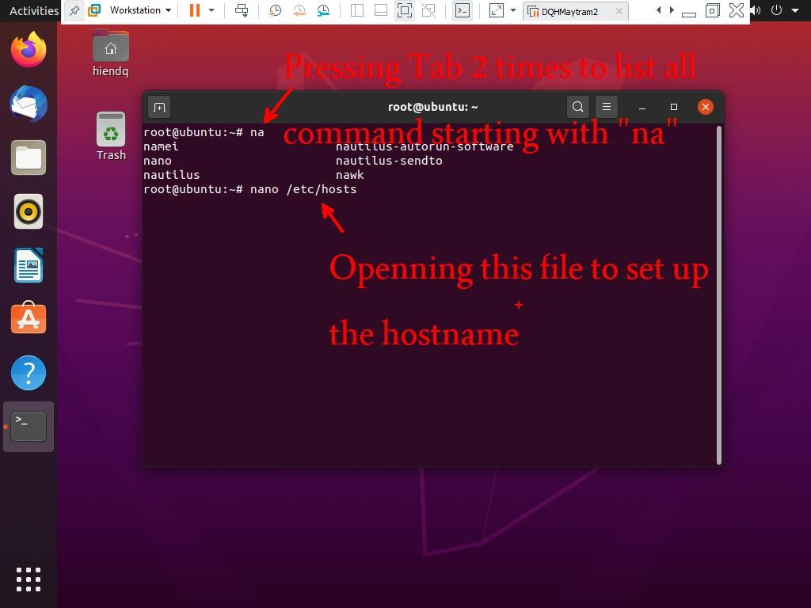

* + Pressing Enter.

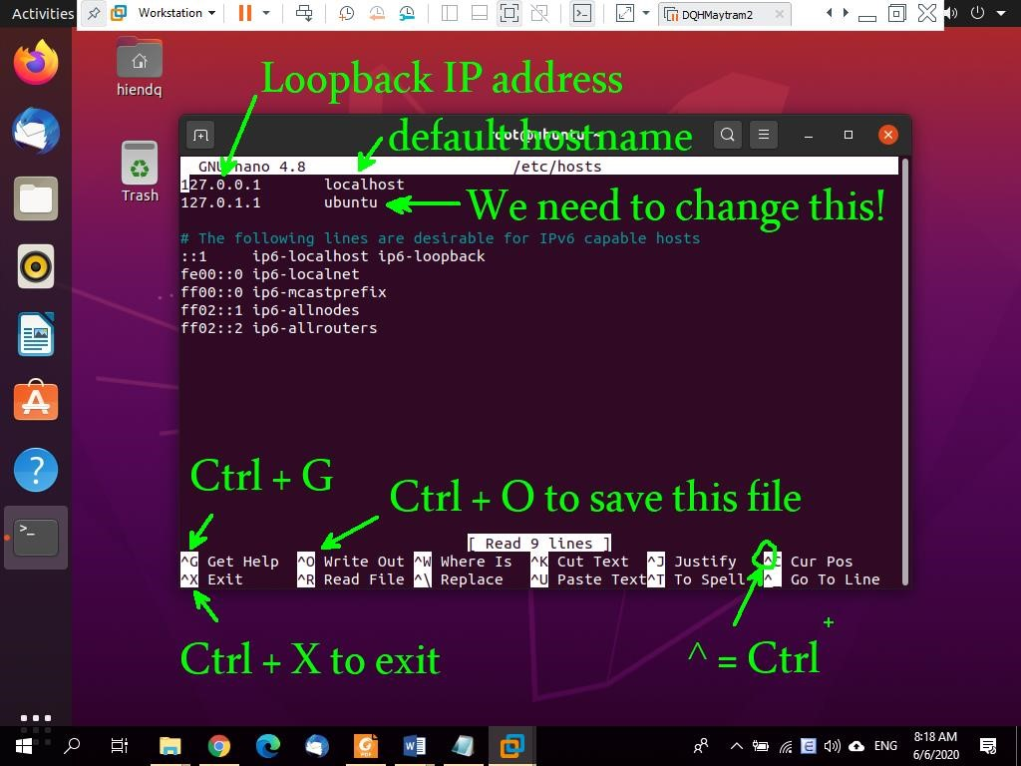

* + Replacing “ubuntu” to your student ID. For example, my student ID is DE9999.

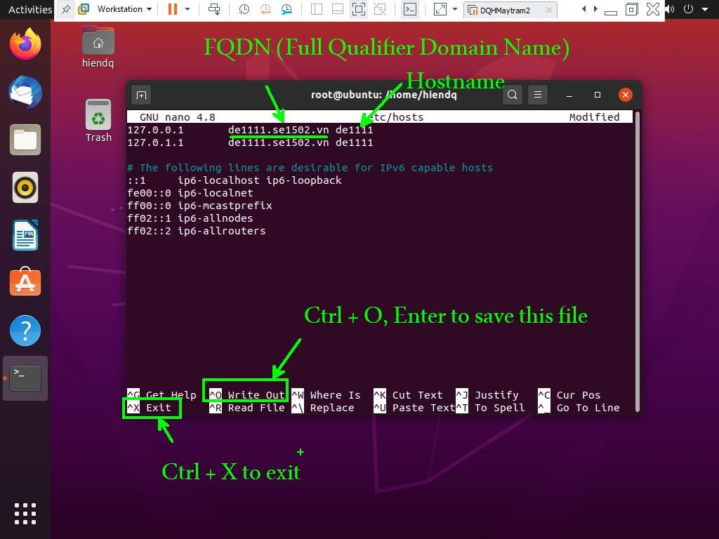

* + Changing the hostname from the file /etc/hostname by using the command *#nano /etc/hostname*.

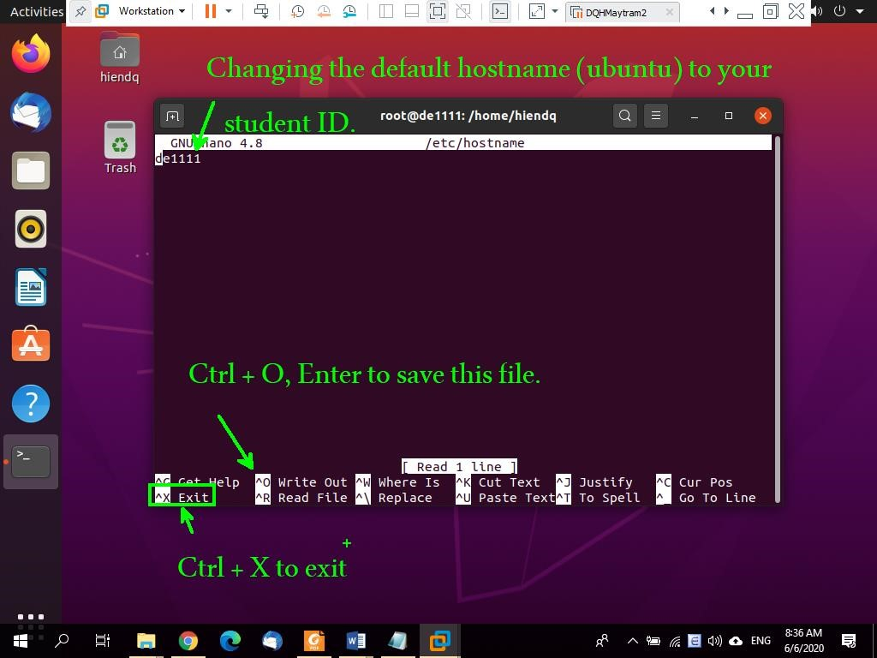

* + Restarting the system by using the command #*reboot.*

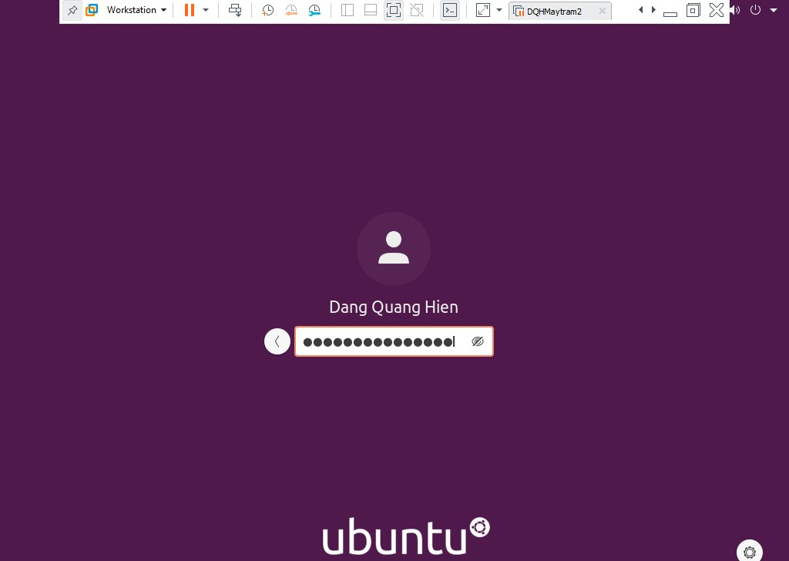

* + After logging the system by root account, using the command *#hostname* and *#hostname –f* (-f stand for FQDN) to see the hostname and FQDN of the system.

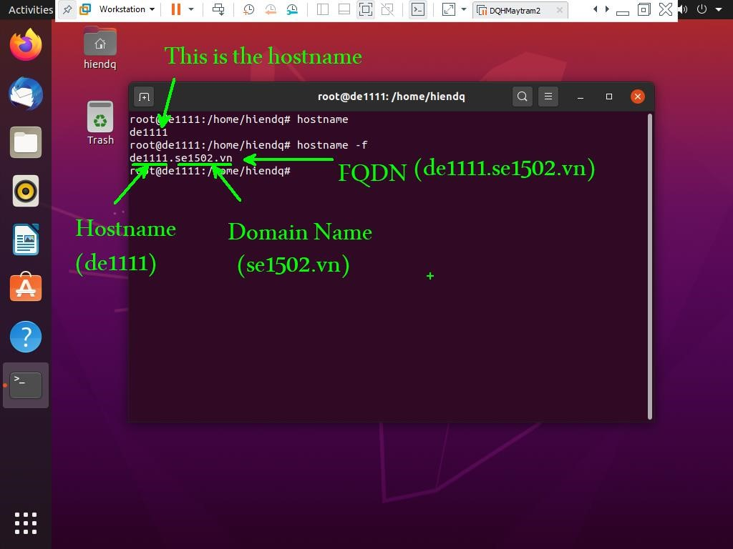

1. Network configuration:
   * Press Ctrl + D or VM > Settings to open Virtual Machine Settings windows:

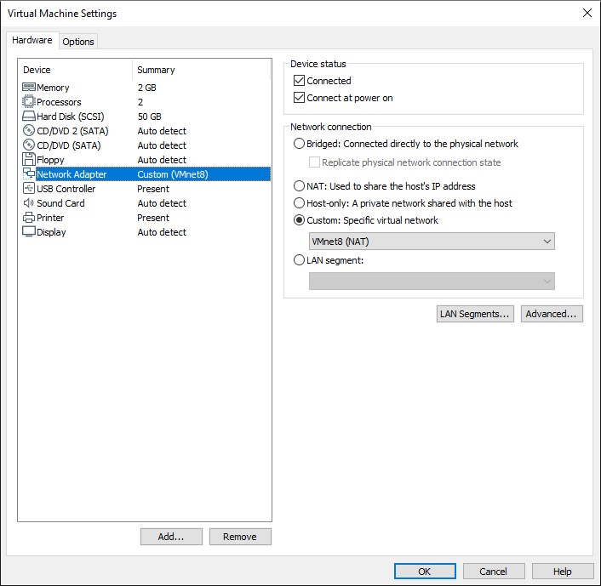

* + Click Network Adapter and choose Custom: Specific virtual network with VMnet8 (NAT). Click OK.

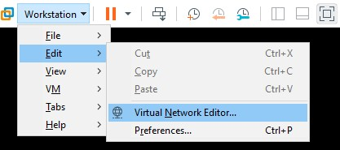

* + Then **Edit > Virtual Network Editor**… to configure default gateway and NAT settings.

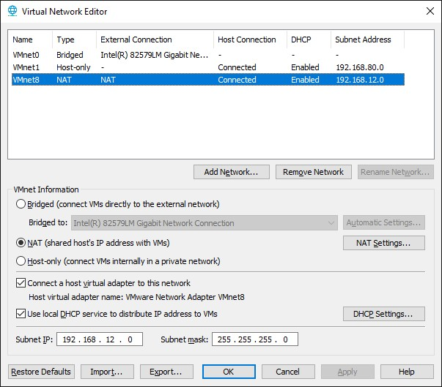

* + Click **VMnet8 (NAT)**. In the Subnet IP, we change the default IP address to 192.168.12.0 and SM (Subnet mask) to 255.255.255.0. Then click Apply. After that, we click to **NAT Settings…**

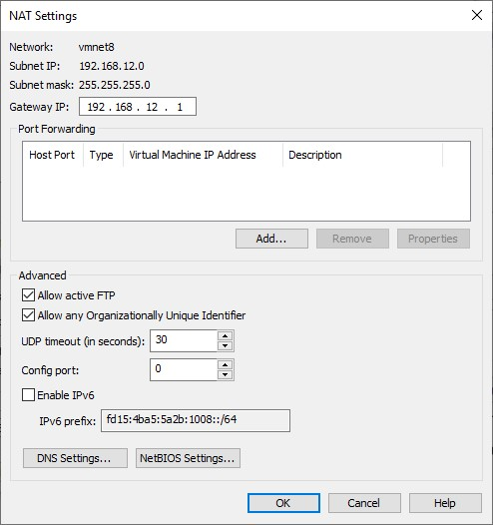

* + In **Gateway IP**, change the default value to 192.168.12.1. Click OK. So the virutal machine belongs to VMnet8 with default gateway is 192.168.12.1/24. Click OK > OK. After that, openning Network and Sharing Center windows:

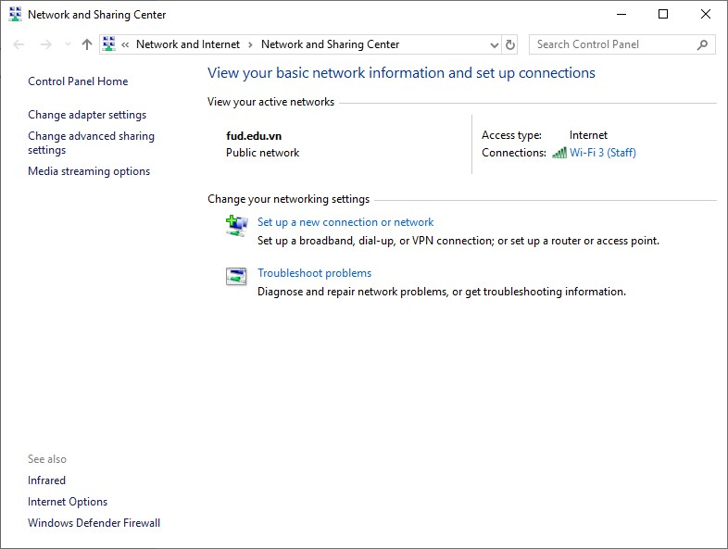

* + Click to Change adapter settings.

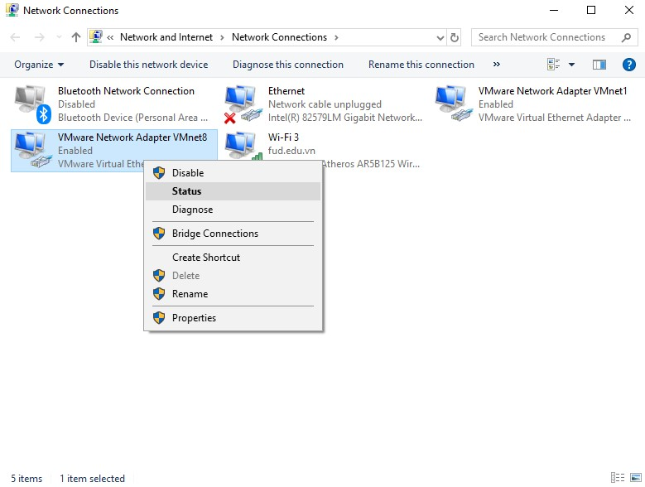

* + Right click to VMnet8 NIC and choose **Status**.

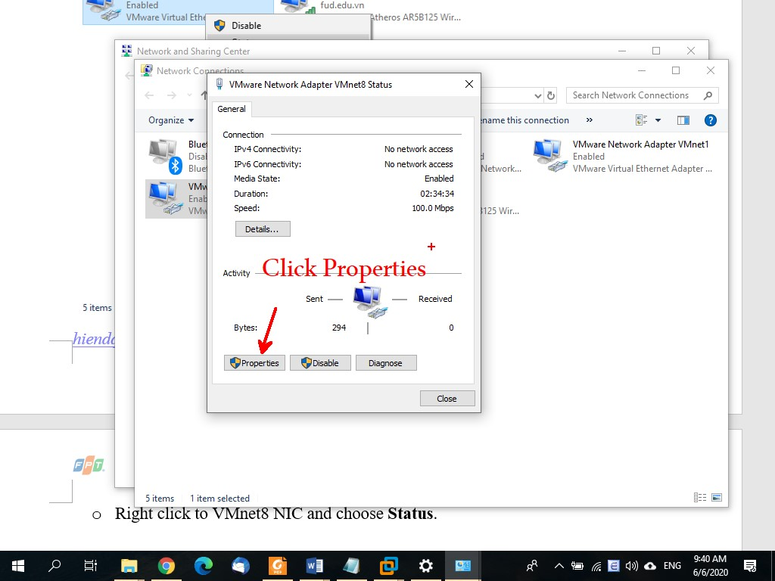

* + Click Properties button.

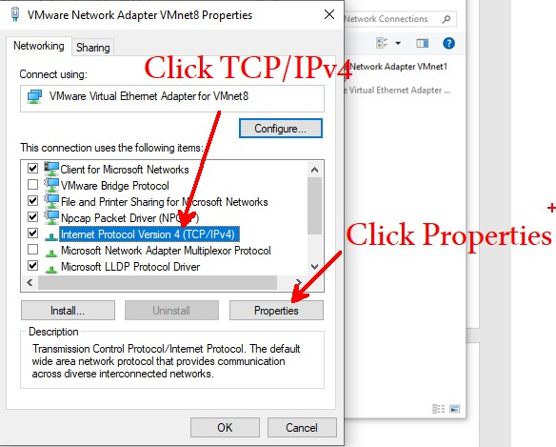

* + Click Properties to change IP information.

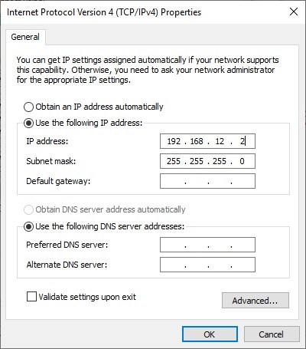

* + In the **IP address**, changing the default value to 192.168.12.2. Click OK > Close > Close. Reboot the VM first. After that, go back to VM and type *#ip address* to see IP information.

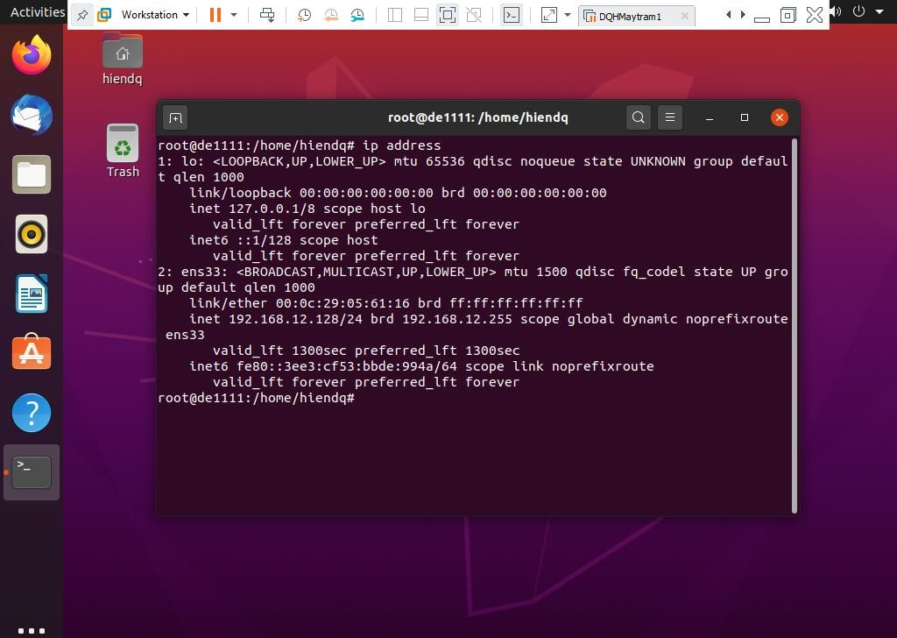

* + The IP address of this VM is 192.168.12.128/24. To check the Internet connection, we use the command #ping 8.8.8.8.

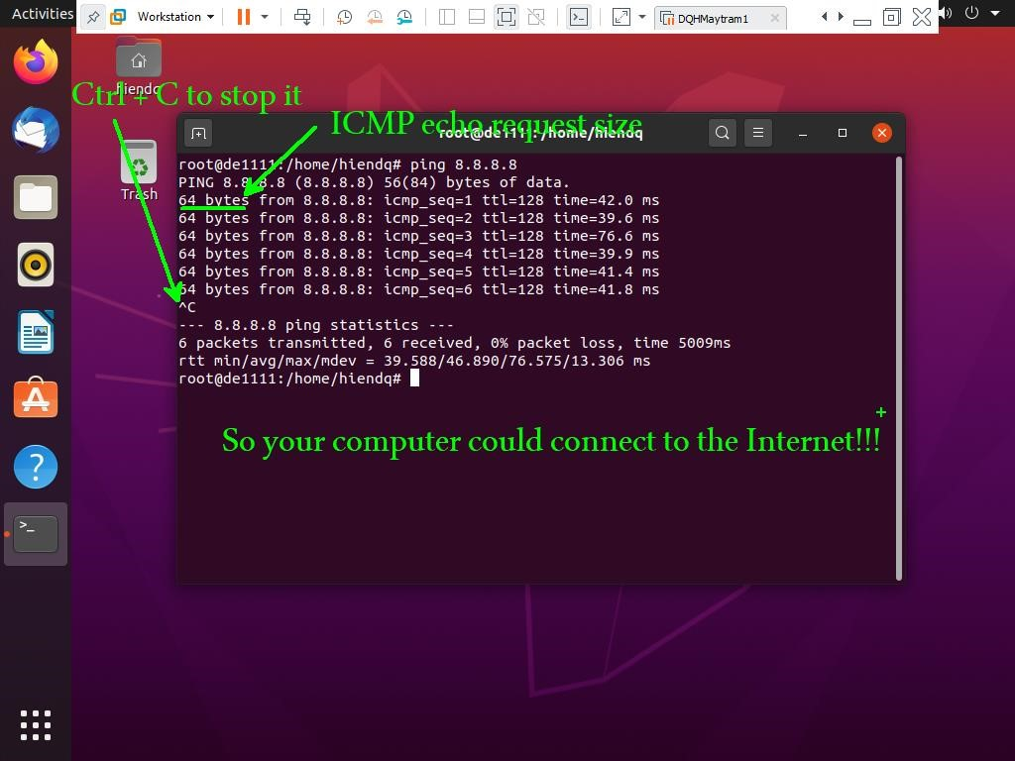

1. Basic Linux commands:

• The command **adduser**

* + - Creating a new user by using your name. For example: if your name is Luong Son Ba then the username will be bals. My name is Chuc Anh Dai then the username would be daica.

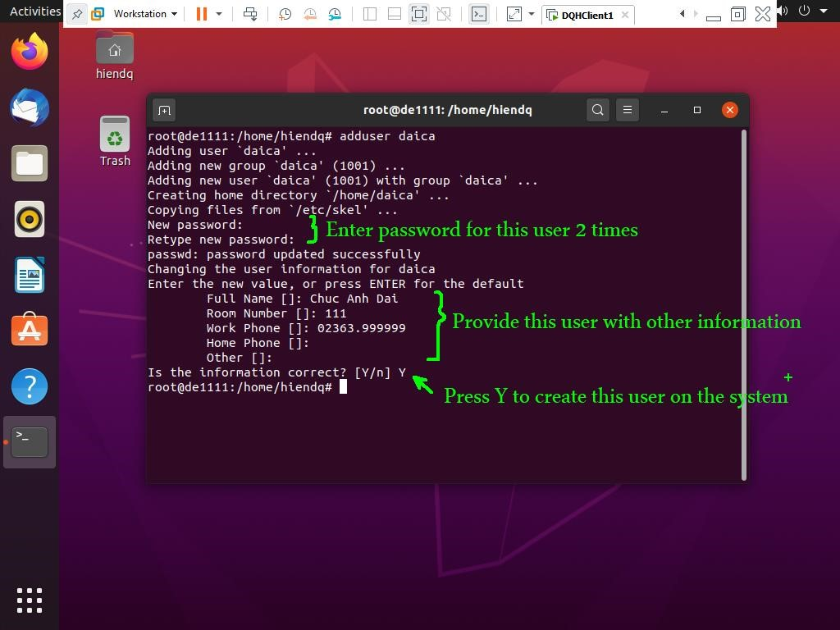

* + - Using *#cat /etc/passwd* to check this username.

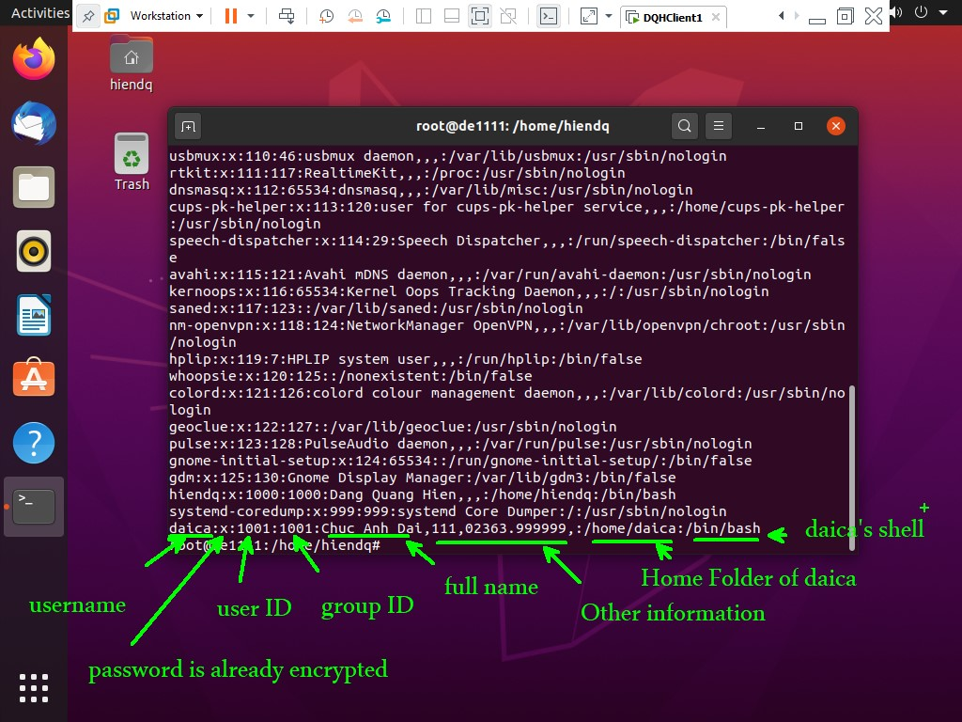

* + - If you want to see the cipher password of daica, you should use the command *#cat /etc/shadow*.

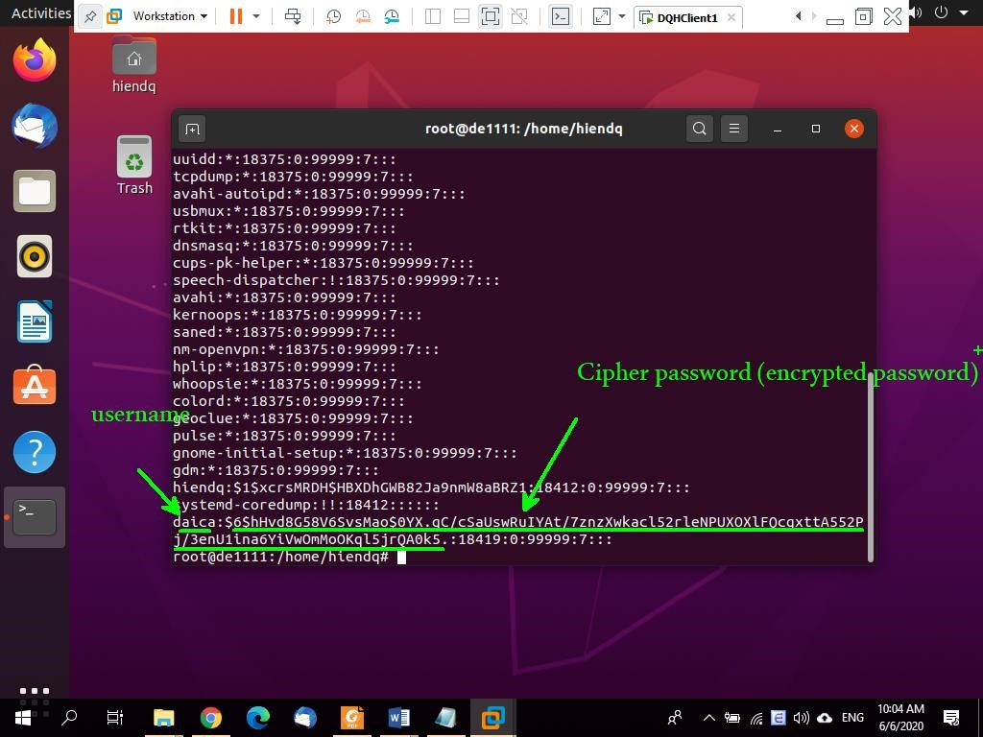

* + - To check the homefolder of this user, we use the command *#dir /home*

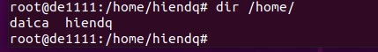

* The command **alias**
  + Using the command *#alias help=man* to substitute the command man by help.

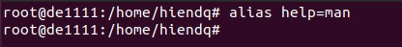

* + Now we could use *#help dir* instead of *#man dir* to see the manual page for the command *man*.

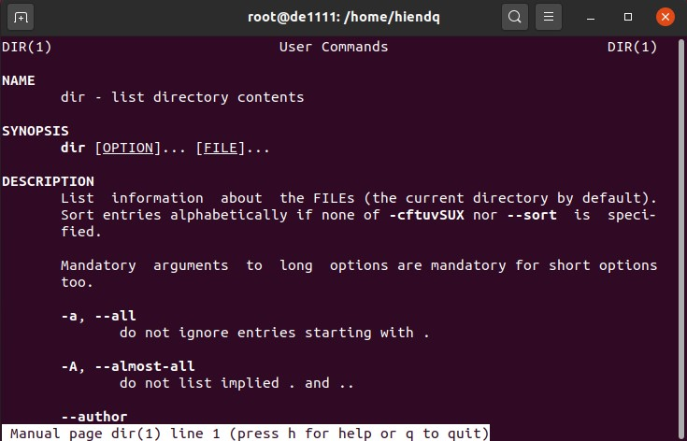

* + Press Q (Quit) to exit.
  + Now we could use *#alias giuptoivoi=man* to substitute the command *man* with *giuptoivoi.*

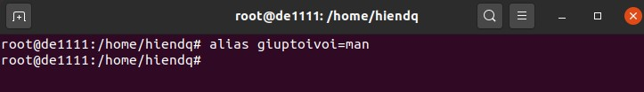

* + Now, we could use *#giuptoivoi ls* to see the manual page for the command ls.

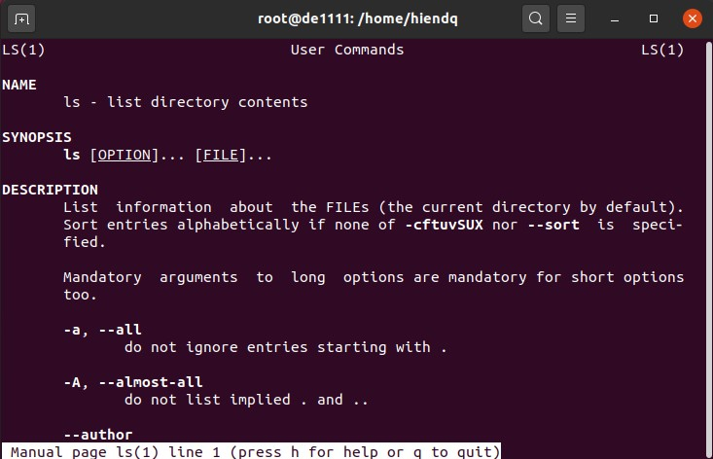

* + Press Q to quit.
* The command **apropos** (apropriate)
  + - Using this command to show the command name based on keyword. For example, looking for the command to zip a file by using the command *#apropos zip* | *more****.***

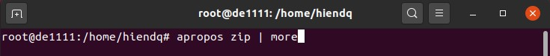

* + - And the result as the following page:

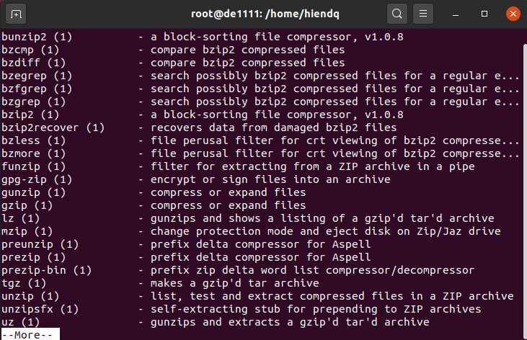

* + - Press Enter to show line by line or Space bar to show page by page. Press Q to quit.
* The command: at
  + - Using the command *#date* to show the current time first.

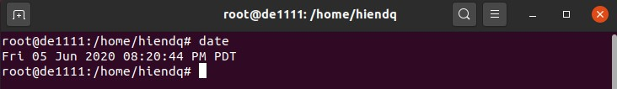

* + - By default the command *at* is not installed on the system. So, we should install this package by using the command *#apt install at*

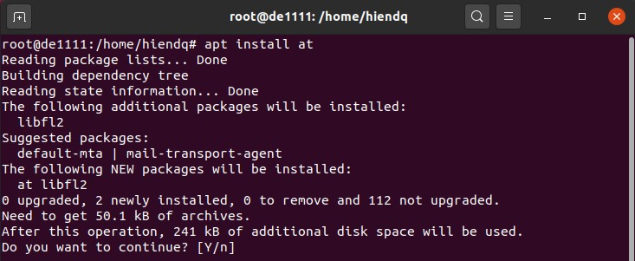

* + - Press “Y” (Yes) to accept and install this package.

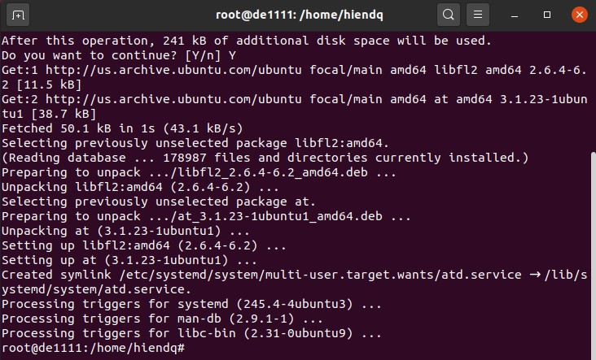

* + - After finishing this command, using the command *#at 8:25 dir /home*
* The command: cat (concatenate)
  + - Using the command *#cd* to return home folder of root.

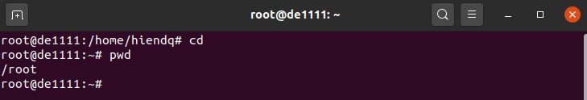

* + - We use the command *#cat > test1.txt* to create the file text1.txt in /root.

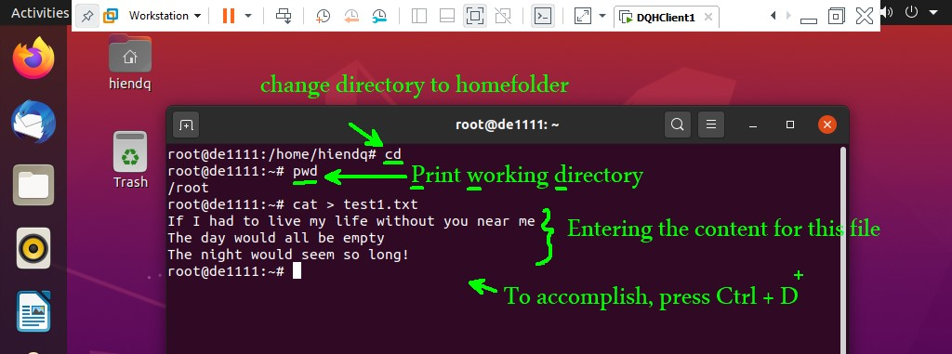

* + - To show the content of this file, we use the command *#cat test1.txt*

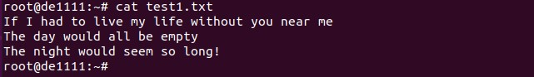

* + - To append more content to this file, we use the command *#cat >> test1.txt.*

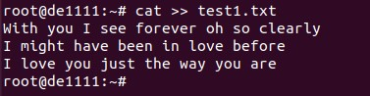

* + - To show the content of this file, we use the command *#cat test1.txt*.

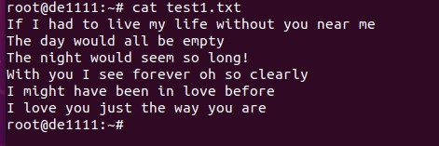

* The command: cd (Change Directory)
  + - Change the current directory to /tmp by using the command *#cd /tmp.*

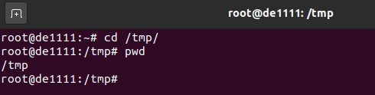

* + - Go back to /root directory by using the command *#cd /root*

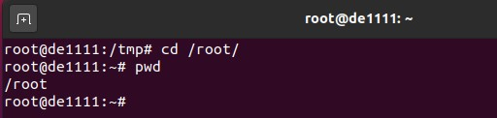

* The command: chfn (change full name)
  + - We use this command to change information related to an username on the system. For example, change home phone number for daica from previous one to 02363.888888.

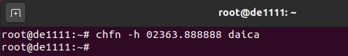

* + - Or changing the fullname of daica from Chuc Anh Dai to Chu Anh Dai.

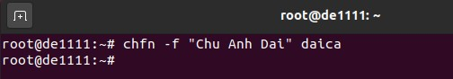

* + - Checking the information by the command #*cat /etc/passwd | grep daica*

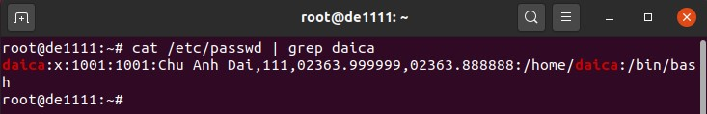

* The command: chmod (change file mode bit)
  + - To show mode bit of the file test1.txt, using the command *#ls -l test1.txt*

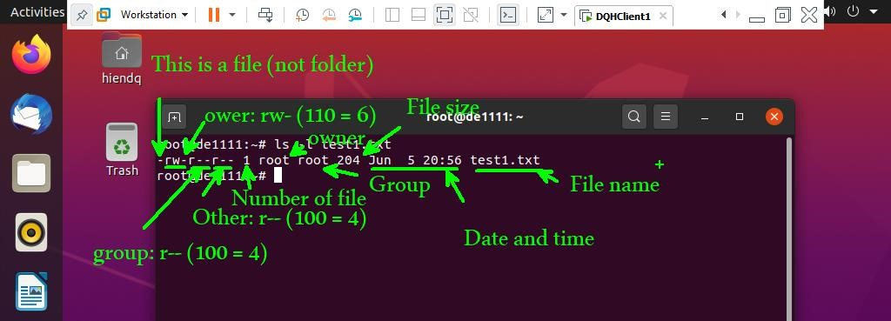

* + - To change the mode bit for this file to 777 (111-111-111), we use the command *#chmod 777 test1.txt.*

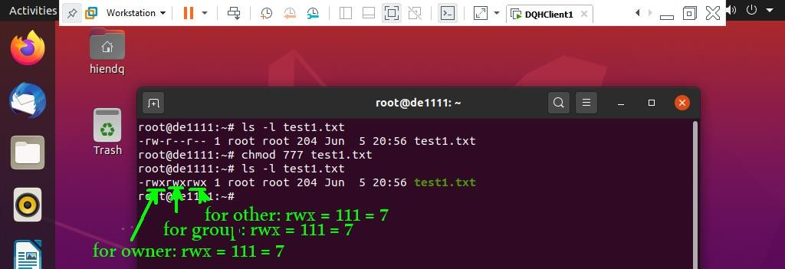

* + - If you want to allow the owner has full permission while group and other only have read and execute permissions, we could use the command *#chmod 755 test1.txt.*

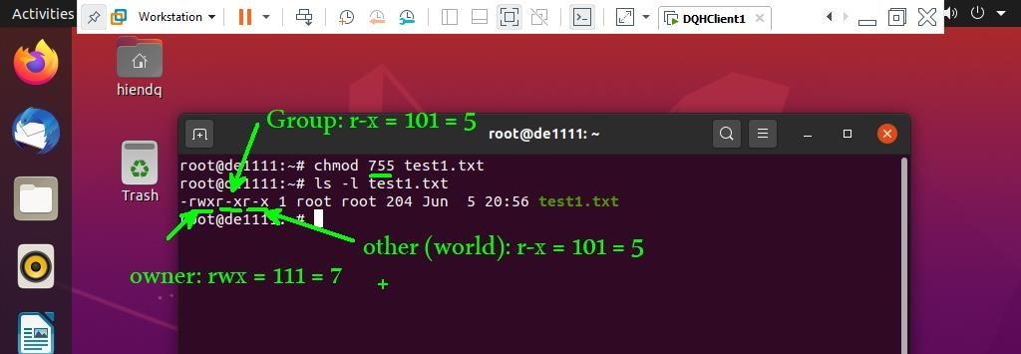

* The command: chown (Change file owner and group)
  + - Now, we create a new file in /home by using root account.

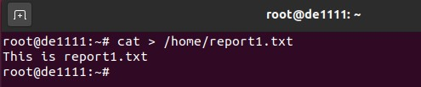

* + - Checking this file permissions by using the command *#ls –l /home/report1.txt*

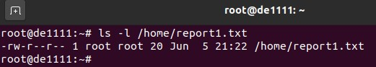

* + - As you can see, the owner:group of this file is root:root. We could change the owner from root to daica by using the command *#chown daica*

*/home/report1.txt*

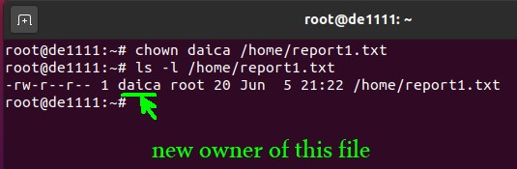

* The command: clear

✓ Using this command to clear the screen.

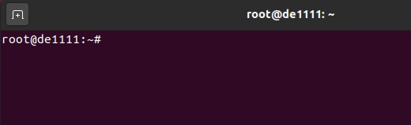

* The command: cmp (compare)
  + - Changing the current directory to /home. After that, we will create a new file report2.txt with the content: “This is report2.txt”.

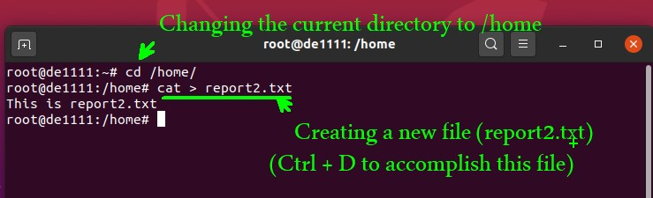

* + - Comparing 2 these files (report1.txt and report2.txt) by using the command *#cmp –b report1.txt report2.txt.*

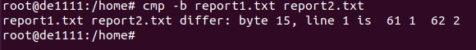

* The command: cp (copy)
  + - Copying the file /home/report2.txt to the folder /tmp by using the command *#cp /home/report2.txt /tmp*

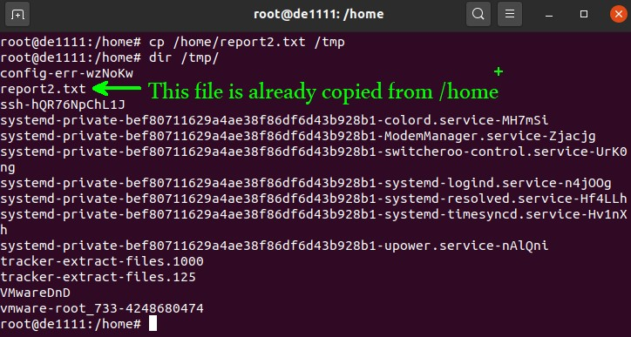

* + - Comparing 2 files: /home/report2.txt and /tmp/report2.txt by using the command *#cmp –b /home/report2.txt /tmp/report2.txt.*

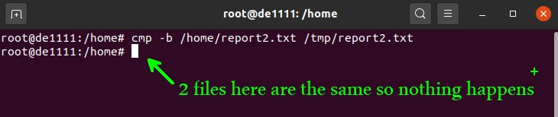

* The command: cpio (Copy files to and from archives)
  + - Copying all files from /etc to /home/daica/daica-backup-2020.05.cpio by using the command #*find /etc -depth -print | cpio -ov > /home/daica/daicabackup-2020.05.cpio.*



* + - Using the command #*ls /home/daica* to check the file daica-backup2020.05.cpio which has been created there.



* + - If we want to restore all the files in the backup file to /etc, we could use the command *#cd /etc | cpio -iv < /home/daica/daica-backup-2020.05.cpio.*



* The command: crontab (maintain crontab files for individual users)
  + - Standing on root account, using the command #*cd* to return homefolder of root. After that, we use the command *#pwd* to print working directory and *#dir* to show the /root content.

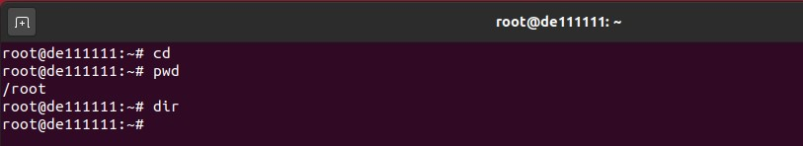

* + - Using the command #*crontab -l* to list all contab of current user.

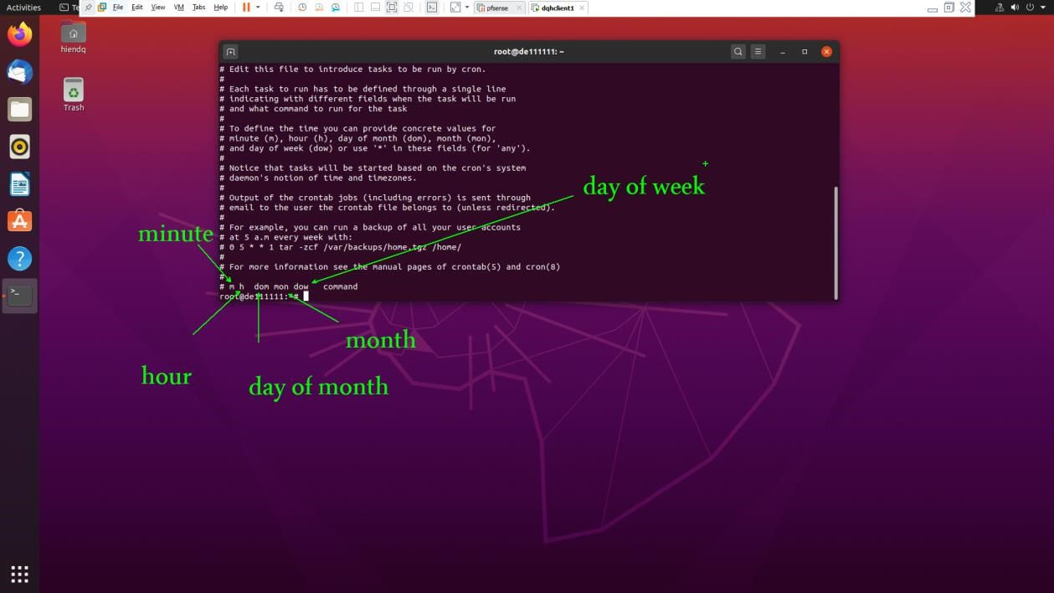

* + - Currently, we do not have any job here. Using the command *#crontab -e*

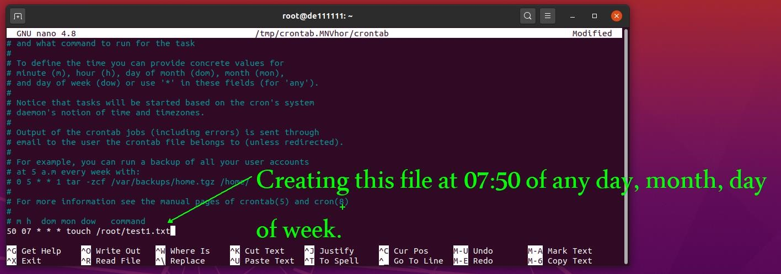

* + - Press Ctrl + O, Enter to save this file. Press Ctrl + X to quit this file. And wait ... until 07:50 then we list the content of /root to see the result. We could check the current time by using the command #*date*

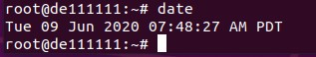

* + - It’s time to check the content of root. Using the command *#ls /root*

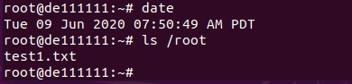

* The command: du (estimate file space usage)
  + - Using the command #*du /root/test1.txt* to see the summarize disk usage of the file.

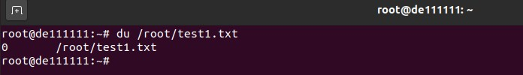

* + - Appending more content to this file by using the command #*cat >>*

*/root/test1.txt.*

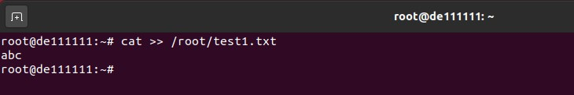

* + - Checking the disk usage of the file again.

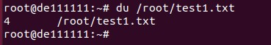

* The command: df (disk free)

✓ This command is used to display the total size, used and available space on all mounted file systems.

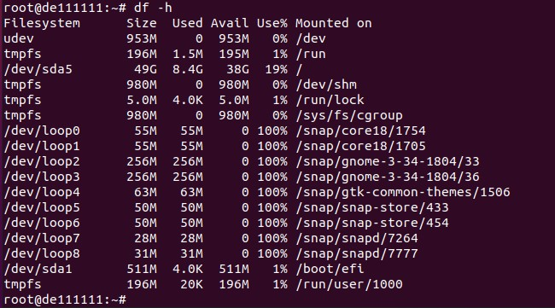

* The command: file (determine file type)
  + - Checking file type of the file /root/test1.txt, using the command #*file*

*/root/test1.txt*

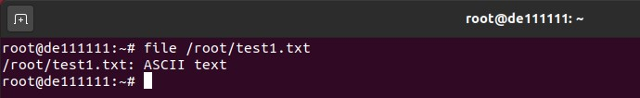

* + - This file is ASCII text file.
* The command: find (search for files in a directory hierarchy)
  + - To find all ASCII text files with extension file type is .txt on the system, we use the command #*find / -name *.txt*

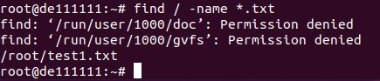

* + - To find all script files in folder /etc, we use the command #*find /etc -name *.sh*

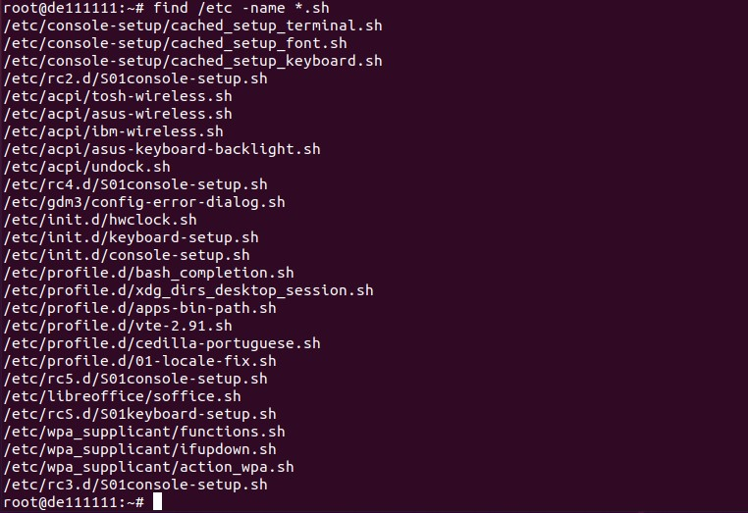

* The command: finger (list all users currently logged into the UNIX system) ✓ Using the command #*finger* to list all users currently logged into the system.

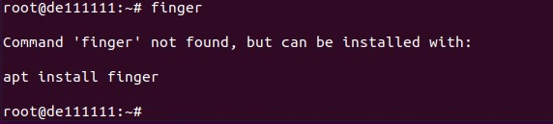

* + - To install this package, we use the command #*apt install finger*

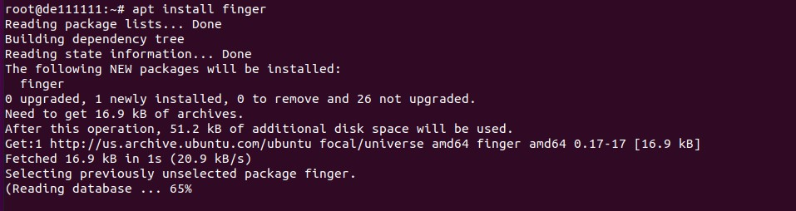

* + - Now we could use the command #*finger*



* The command: free (Display amount of free and used memory in the system)
  + - Using the command #*free* to see amount of free and used memory in your system.

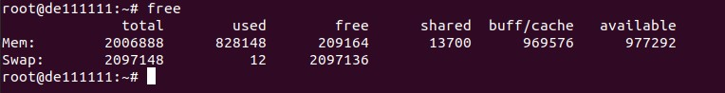

* + - If we want to see the capacity in megabyte, we use option “-m” like this #*free -m.*

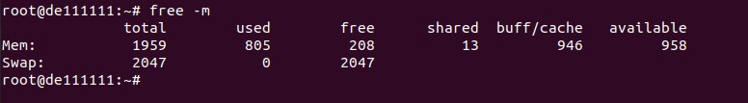

* The command: grep (This searches for and limits the command output to the pattern specified).
  + - Using the command #*cat /etc/passwd | grep daica* to show only instance of daica from the file /etc/passwd.

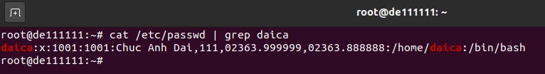

* + - We could add more content into the file /root/test1.txt by using the command #*cat >> /root/test1.txt****.*** After that, we could show lines which consist of “empty” by using the command *#cat /root/test1.txt | grep empty.*

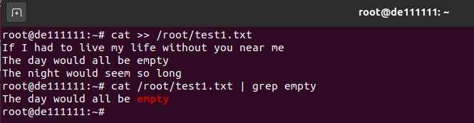

* + - And more...

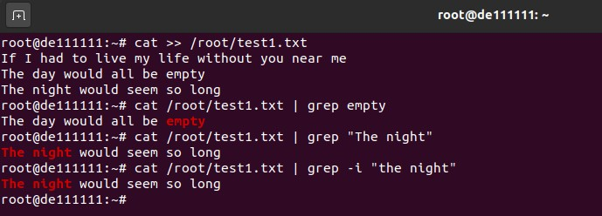

* The command: groups (Shows which groups you are in) ✓ Checking the group of user daica

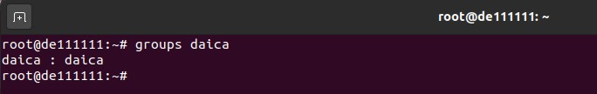

* + - Checking the group of user root and the user you created during the installation time.

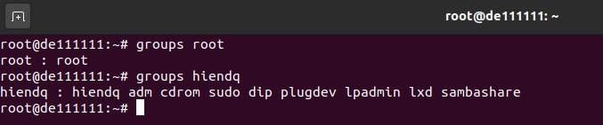

* + - Because user daica does not belong to group sudo, daica can not use *sudo* (select supper user to do) by default. We could add user daica to group sudo by using the command #*usermod -a -G sudo daica*.

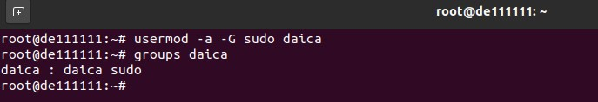

* + - Using sudo for daica

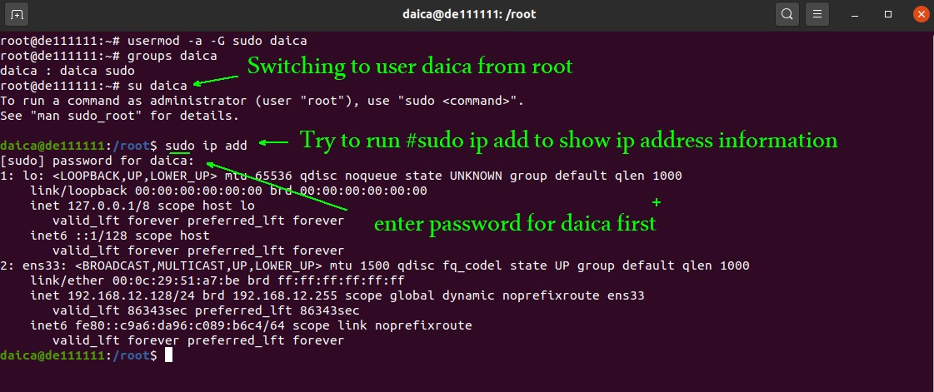

* The command: groupadd (Create a new group)
  + - Using the command #*cat /etc/group | grep marketing* to check whether group **marketing** hasalready existed or not on the system.

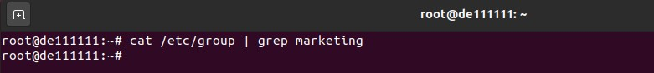

* + - Creating this group by using the command #*groupadd marketing*

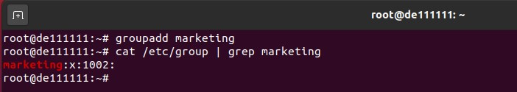

* + - We could check this grop by using the command #*cat /etc/group | grep marketing.* Now it is time to add the user daica into this group by using the command #*usermod -a -G marketing daica.*

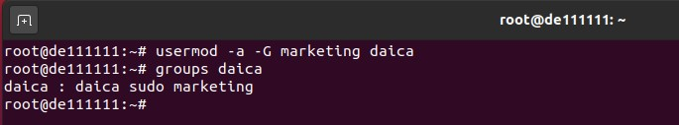

* + - So the user daica belongs to 3 different groups (daica, sudo, marketing).
* The command: gzip (compress or expand files)
  + - Changing the current directory to /home/daica and then listing the content of this folder first.

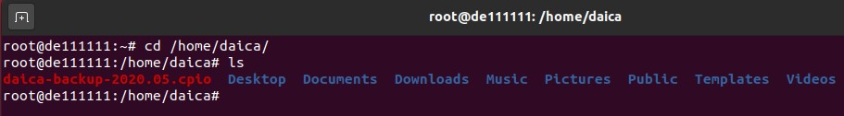

* + - Now we use the command #*gzip daica-backup-2020.05.cpio* to give it the extension daica-backup-2020.05.cpio.gz.



* + - Later, if you would like to decompress this file you could use this command with the option “-d” (decompress).



* The command: hostname (show or set the system’s host name)
  + - To show the host name which is stored in the file /etc/hostname, we use the command #*hostname*

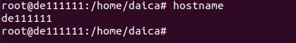

* + - If we want to show FQDN of this system, we could use the option “-f” (FQDN).

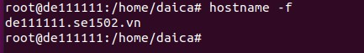

* The command: ifconfig (interface configuration)
  + - First of all, we need to install this package by using the command #*apt install net-tools*.

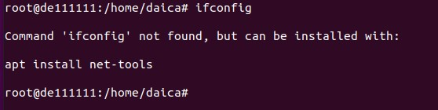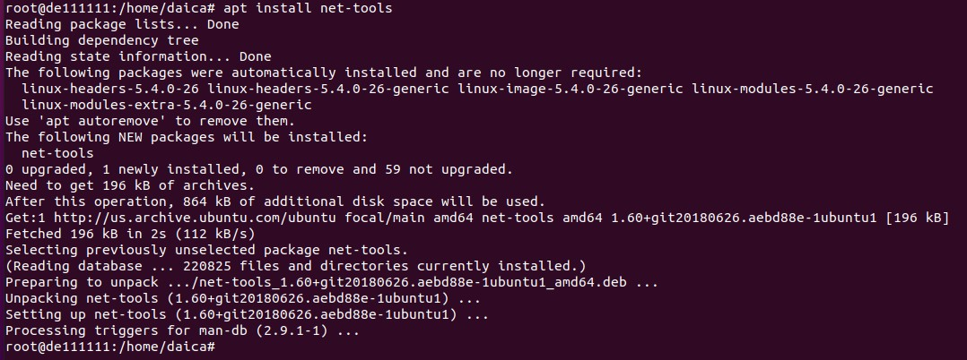

* + - To show IP information of NICs on the system, use the command #*ifconfig*

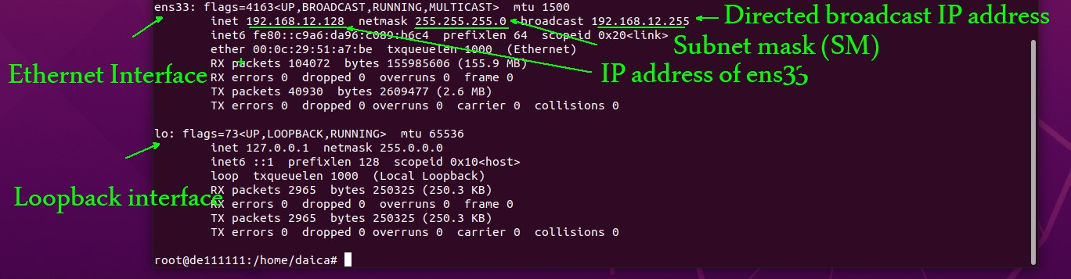

* The command: last (Showing the last logged in users on the system)
  + - Using the command #*last –t today* to see all logged users today in the system.

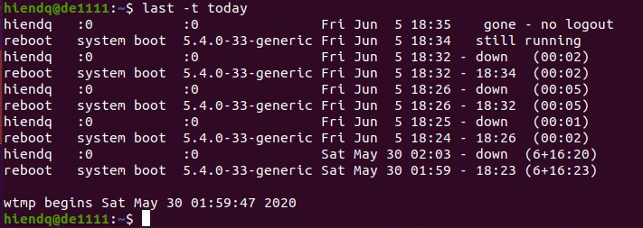

* + - Using the command #*last reboot* to see all logged users since the last reboot time.

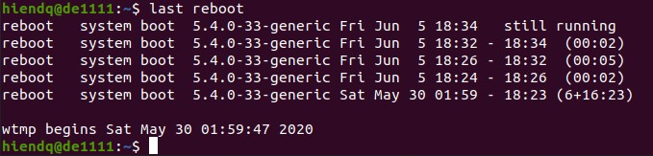

* The command: lastlog (report the most recent log in of all users or a specified user).

✓ Using the command #*lastlog | more* to report the most recent log in of all users on the system.

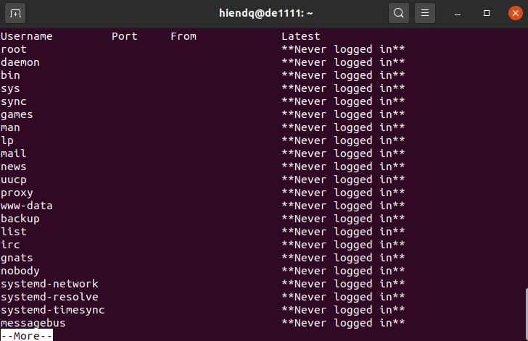

* The command: more and less (to show the file content page by page)
  + Using the command #*more /etc/passwd* to show the content of this file in separated pages.

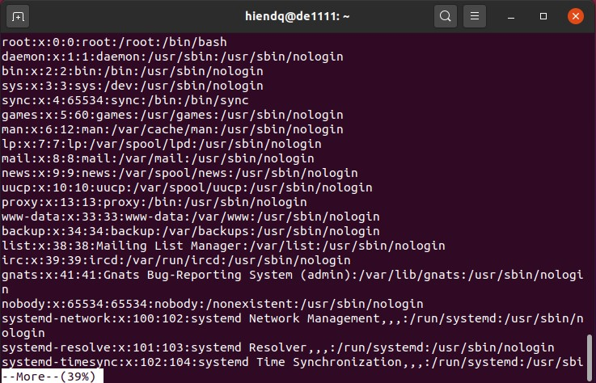

* + Pressing Enter to see more lines or Space bar to see more pages from this file. And press Q to quit.
  + The command less that opposite of more. And this command has more features than *more* command.

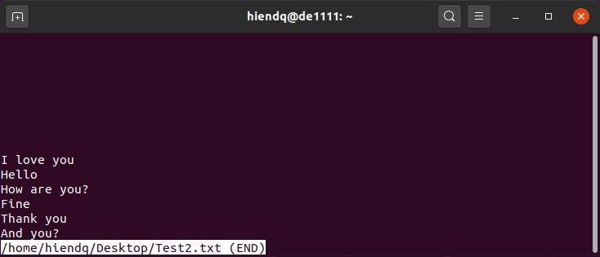

* + Administrators often use this command to show log file such as #*less /var/log/syslog.*

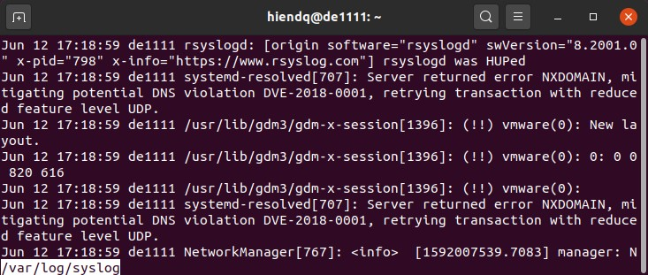

* The command: ln (link)
  + - First of all, we change from current user to **root** user by using the command #*su root.*

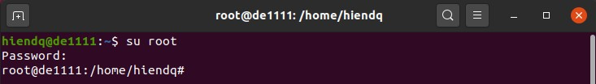

* + - Making a new folder that could be used to link /home/daica into by using the command #*mkdir /home/folder_ln.*

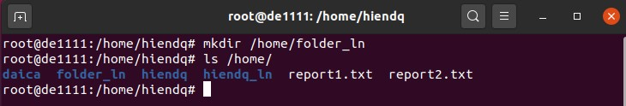

* + - Now, we make a soft link from folder_ln into /home/daica.

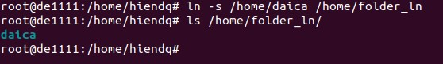

* The command: ls (Listing the content of a folder)
  + - Using the command #*ls /home*to show the content of the folder /home.

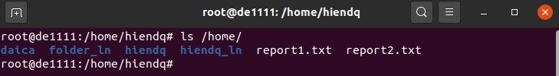

* + - Using the command #*ls –la /home* to show all the content including hidden files and folders.

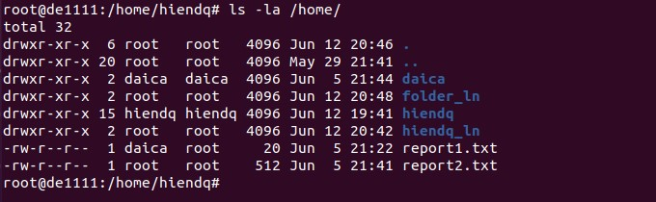

* The command: lsmod (Listing current kernel modules on the system).

✓ Using the command #*lsmod | more* to list all the current kernel modules loaded on this system.

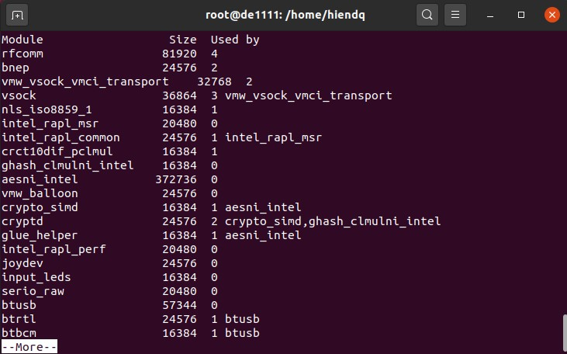

* The command: mkdir (Making directory)

✓ Changing the current directory to /home/daica. Then we create folder Report by using the command #*cd /home/daica, #mkdir Report.*

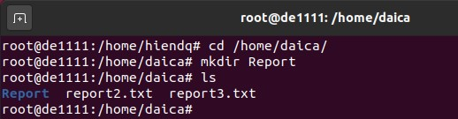

* The command: mv (Move)
  + - We use the command #*cd* to return root homefolder first. Then we list the content of this folder.

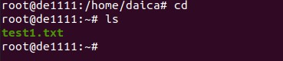

* + - In /root, we have a file test1.txt. Now, we move this file from /root to /home/daica by using the command #*mv test1.txt /home/daica.*

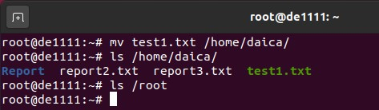

* The command: nice (It is used to change the scheduling priority) ✓ Using the command #*top* to see top priorities on the system first.

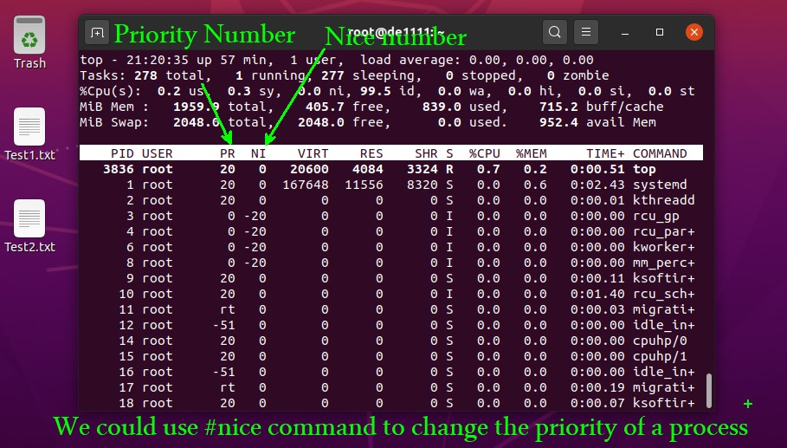

* + - We could see that the Nice number of command *top* is 0. We could change this nice number from 0 to 10 by using the command #*nice -10 top.*



* + - As you can see the nice number is already changed from 0 to 10.
* The command: passwd (Password)

✓ We use this command to change the password of an user on the system. For example, if you want to change the root’s password you could use the command #*sudo passwd root.*

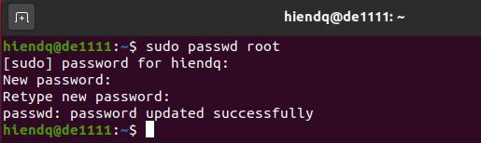

## 1.4 Questions

1) What is the main characteristic of embedded operating system?

1. Multiple CPU
2. Time-sharing
3. Many I/O devices
4. Restriction of memory size, speed of CPU, screen size, powers 2) What is the below five statements described?

1. Put the argument of called function on the stack 2. The interrupt occurs to switch from user mode to kernel mode

* 1. The system functions are located and executed.
  2. After finished, the interrupt occurs again to switch to user mode
  3. The control is returned to the called function

1. System environment
2. System programs
3. User interfaces
4. The interface between user programs and the OS is used to call the special procedure in kernel
5. ____ is a sort of pseudo-file that can be used to connect to processes
   1. A. A block
   2. B. A pipe
   3. C. A specific file
   4. D. A block file
6. Which is the difference between personal computers and mainframe computers?
   1. Personal computers are always interactive
   2. Mainframe computers are mostly batch systems with many users
   3. Protection is much more important on mainframe computers
   4. All of the others
7. What is not a main component of an operating system?
   1. Provide user interfaces
   2. File management
   3. Manage the I/O devices
   4. Process management
8. MSDOS is a example of _____
   1. Monolithic system
   2. Layered System
   3. Virtual Machine
   4. Clientserver model
9. Which of the following statements is incorrect about user mode and kernel mode?
   1. In kernel mode, the OS can execute every instruction in the instruction set
   2. In user mode, user program can execute only a subset of instructions
   3. Having two modes of operation helps prevent user programs from accessing critical instructions
   4. None of the others
10. A timesharing system is _____
    1. Another name for a batch system
    2. A multiuser, multiprocess, interactive system
    3. All of the others
    4. None of the others
11. Which of these statements about Microkernel are true?
    1. The modules run user mode `\rightarrow` protection against bugs
    2. All the layers went in the kernel
    3. Resist crashing the entire system
    4. All of the others
12.  are used to model devices that consist of a collection of randomly addressable blocks such as disks
    1. A character special file
    2. A separate special file
    3. A pipe special file
    4. A block special file
13.  is the rapid switching of the CPU between multiple processes in memory
    1. Multiprogramming
    2. Multipaging
    3. Multiprocesses
    4. Multischeduling
14. Which of these statements about Microkernel are not true?
    1. Resist crashing the entire system
    2. Achieve high reliability by splitting the OS into small, welldefined modules
    3. The modules run user mode to protection against bugs
    4. None of the others
15.  are used to model printers, modems, and other devices that accept or output a character stream
    1. A character special file
    2. A separate special file
    3. A block special file
    4. A pipe special file
16. The layers in Layered System are 
    1. Operator-process communication, User programs, and Processor allocation and

multiprogramming

* 1. Procedure management, User programs, and Processor allocation and multiprogramming
  2. File management, Operator - process communication, and Processor allocation and multiprogramming
  3. Service management, and Operator -process communication, User programs

1. Which type of OS structure does give each user a subset of the resource instead of exact copying entire of underlying real machine? a) Virtual Machine
   1. Extend Kernel
   2. Extra Kernel
   3. ExoKernel
2. The OS is written as a collection of procedures, linked together into a single large executable binary program. Which OS structure is described ?
   1. MSDOS
   2. Monochrome
   3. MonoOS
   4. MonoKernel
3. The shell is 
   1. A piece of software that essentially provides a kind of interface for end users
   2. A piece of firmware that essentially provides a kind of interface for end users
   3. A piece of hardware that essentially provides a kind of interface for end users
   4. Rigid outer covering of an animal
4. The  is a file that contains a list of shell command be executed in order a) Shell scripts
   1. Shell commands
   2. None of the others
   3. All of the others
5. What is the mechanism? 1. The mechanism ensures that all access to system resources is controlled. 2. The mechanism detects latent errors at the interface between component subsystems. 3. The mechanism protects the system from unwanted intruders.
   1. Protection
   2. Address space
   3. Pipes
   4. I/O management
6. OS manage the system security such as authentication, protecting the system from unwanted intruders. a) Security
   1. Authentication
   2. Protection
   3. Block access
7. Put the steps in making a system call in order
   * + 1. System calls may vary from one OS to another
     + 2. System calls are like procedures: take parameters, calling routine waits for response (a call to an OS service)
     + 3. Once a system call occurs control passes to a specific routing in system mode. If the parameters are correct and legal the request will be executed (a trap into the OS code)
   1. 1, 2, 3
   2. 2, 3, 1
   3. 3, 1, 2
   4. 3, 2, 1
8. Each process is associated with 
   1. address space, set of resources, registers, etc
   2. address space, set of program's source files, pointer, etc
   3. address memory, linker, compiler, ...
   4. All of the others
9. is a small computer that fits in a shirt pocket and performs a small number of functions, such as an electronic address book and memopad a) Personal Computer
   1. Personal Device
   2. Personal Operating System
   3. Personal Digital Assistant
10. A  is provided to make system calls from some programming languages a) procedure library
    1. operator
    2. pointer
    3. None of the others
11. Where is all the information about each process stored in operating systems? a) Virtual table
    1. Page table
    2. Process table
    3. Program table
12. Which operating system structure is communication between requesting process and responding process by message passing? a) Client Server Model
    1. Monolithic Systems
    2. MS DOS
    3. All of the others
13. Which of the following statements is incorrect about timesharing and multiprogramming systems?
    1. In a timesharing system, multiple users can access the system simultaneously
    2. In a multiprogramming system, one user can run several processes simultaneously
    3. All timesharing systems are multiprogramming systems
    4. All multiprogramming systems are timesharing systems
14.  is the partitioning of a single server, each of which can support a different operating
    1. Multiprocessing
    2. Multithreading
    3. Virtualization
    4. Shared processing
15. As one proceeds down the memory hierarchy (from inboard memory to offline storage), the following conditions apply: a) Increasing cost per bit
    1. Decreasing capacity
    2. Increasing access time
    3. All of the others.
16. The two basic types of processor registers are:
    1. General and special registers
    2. Control and Status registers
    3. Uservisible and userinvisible registers
    4. None of the others.
17. Information that must be saved prior to the processor transferring control to the interrupt handler routine includes:
    1. PSW
    2. PSW and PC
    3. PSW and Contents of processor registers
    4. None of the others.
18. Examples of general purpose stored program computers include the following except a) Personal computers
    1. Network servers
    2. Workstations
    3. MP3 player
19. The term multiprogramming means
    1. Running programs on multiple machines
    2. Switching the CPU between executing programs in order to maximize resource utilization
    3. Allowing multiple users to write programs simultaneously
    4. None of the others
20. Linux and  are often used as operating systems on supercomputers, mainframes, and servers. a) Windows
    1. Mac OS
    2. UNIX
    3. None of the others
21. Which of the following is an Operating System component?
    1. Process Management
    2. Time Management
    3. Space Management
    4. Speed Management
22. Which particular Operating System does not implement the "Process hierarchies" concepts?
    1. Windows
    2. Unix
    3. Both Windows and Unix
    4. None of the others
23. What are the differences between System Calls and System Programs?
    1. System programs are simply user interfaces to system calls
    2. System programs define the view of the OS seen by most users while System

Calls are hidden to user

* 1. All of the others
  2. None of the others

1. Which Operating System structure is applied to Symbian?
   1. Microkernels
   2. Kernels
   3. Layers
   4. All of the others
2. A time-sharing system is _____
   1. Another name for a batch system
   2. A multi-user, multi-process, interactive system
   3. All of the others
   4. None of the others
3. Win32 application programming interfaces is for _____
   1. Windows
   2. UNIX
   3. Linux
   4. Solaris
4. To access the services of operating system, the interface is provided by the _____ a) System calls
   1. API
   2. Library
   3. Assembly instructions
5. _____ offers 3 kinds of services: batch, transaction processing, timesharing.
   1. Mainframe OS
   2. Server OS
   3. PC OS
   4. Multiprocessor OS
6. Server OS serves multiple users at once over a network and allows the user share _____ and _____ resources. a) Firmware, hardware
   1. software, firmware
   2. Firmware, hardware
   3. Hardware, software
7. Main memory of the computer system is also called _____
   1. Non volatile
   2. Volatile
   3. Reserved
   4. Large
8. Which the following one is not true?
   1. Kernel is the program that constitutes the central core of the operating system.
   2. Kernel is the first part of operating system to load into memory during booting
   3. Kernel remains in the memory during the entire computer session
   4. Kernel is made of various modules which can not be loaded in running operating system
9. Which of these statements about the CMOS is not true?
   1. CMOS is volatile
   2. Many computers use CMOS memory to hold the current time and date.
   3. CMOS memory can hold the configuration parameters such as which disk to boot from.
   4. CMOS memory can hold the Assembly instructions.
10. In Client-Server model of the Operating System structure. Communication between clients and servers is often by ______. a) Interrupt
    1. Shared memory
    2. Mapped memory
    3. IRQ
11. What is operating system?
    1. collection of programs that manages hardware resources
    2. system service provider to the application programs
    3. link to interface the hardware and application programs
    4. all of the mentioned
12. Which one of the following is not true?
    1. Kernel is made of various modules which can not be loaded in running operating system
    2. Kernel is the program that constitutes the central core of the operating system
    3. Kernel is the first part of operating system to load into memory during booting
    4. Kernel remains in the memory during the entire computer session 50) What is the main function of the command interpreter?
    5. To get and execute the next user-specified command
    6. To provide the interface between the API and application program
    7. To handle the files in operating system
    8. To provide the interface between application program and hardware
13. By operating system, the resource management can be done via __________
    1. time division multiplexing
    2. space division multiplexing
    3. time and space division multiplexing
    4. none of the mentioned
14. If a process fails, most operating system write the error information to a ______ a) log file
    1. another running process
    2. new file
    3. new folder
15. Which of these statements about the processor is not true?
    1. An x86 processor can execute ARM programs and an ARM processor can execute x86 programs.
    2. Each CPU has a specific set of instructions that it can execute
    3. All CPUs contain some registers inside to hold key variables and temporary results.
    4. The basic cycle of every CPU is to fetch the first instruction from memory, decode it to determine its type and operands, execute it, and then fetch, decode, and execute subsequent instructions.
16. A superscalar CPU is designed to 
    1. interrupt
    2. execute multiple instructions per clock cycle
    3. share memory
    4. map memory
17. Dual mode of operating system has _____
    1. 2 modes
    2. 3 modes
    3. 4 modes
    4. 5 modes

56)

# CHAPTER 2. PROCESSES AND THREADS

## 2.1 Purposes

## 2.2 Requirements

## 2.3 Practice and Questions

#### 2.3.1 Practice

1. Init:

• To show information about process init on the system, using the command #*ps -f 1*

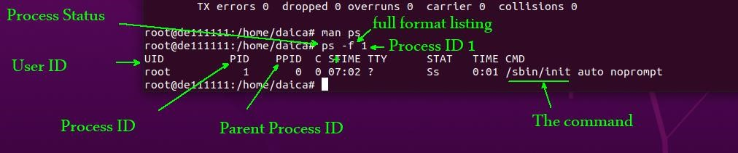

1. Fork and exec:
   * + Fork makes a copy of parent process while exec replaces that process with another process.
     + Opening new Terminal windows by press Ctrl + Alt + T and type the command #*ls* to show the content of the current directory.

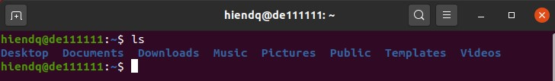

* + - In this example, the parent process (current bash shell) create a copy of it self and run ls command. If we type #*exec ls*, the exec replaces the current process (current bash shell) with another process (ls).

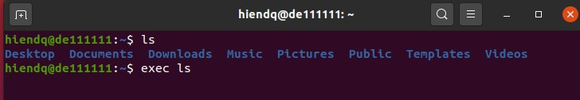

* + - If we press enter right after entering the command #*exec ls*, the windows disappears after the ls command runs on the system.

1. PS (report a snapshot of the current processes)
   * Using the command #*ps* to show all the current process on the system.

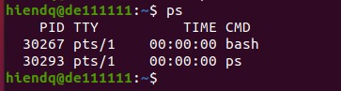

* + Using the command #*ps f* with f (forest) to show ASCII art process hierarchy.

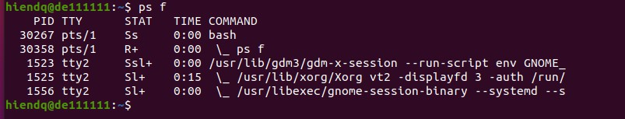

* + If we want to delay all these process for a specified amount of time, we could use the command #*sleep.* For example, we use the command #*sleep 300* to pause for 5 minutes.

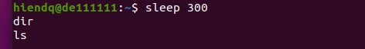

* + During this sleep time, we can not run any other commands on the system. To kill the current process, press Ctrl + C.

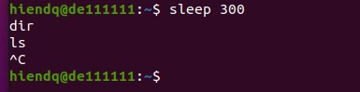

* + If you do not want to end the current process, you could suspend the process with Ctrl + Z instead of Ctrl + C. To check this, re run the command #*sleep 300*, then press Ctrl + Z.

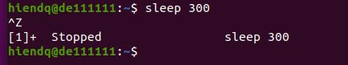

* + To see the suspended process, we use the command #*jobs.*

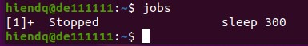

* + If we want this process could run on foreground, we use the command #*fg*



* + The process is running on foreground. If we want to suspend this process again, just press Ctrl + Z.

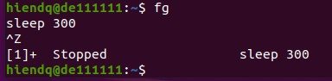

* + To check this status, we use the command #*ps f*

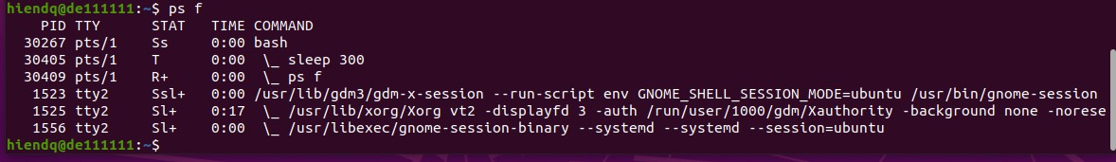

* + The status of this process is Stopped (T). If we would like this process runs again in background, we could use the command #*bg*

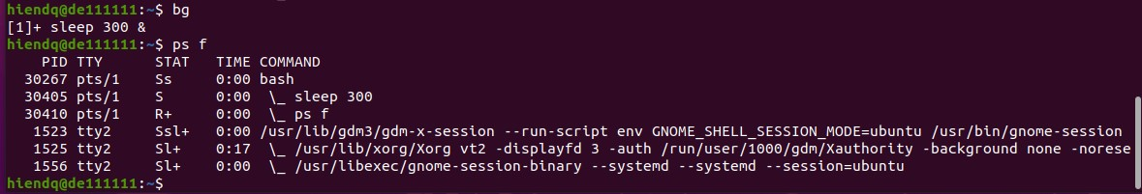

* + After running this process on background, we could check the status of this process by using the command #*jobs* and the status of this process is Running.

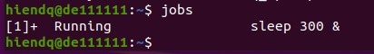

* + If we want to run a process directly in background, we use ampersand (&) at the end of the command. For example, if we want to run 3 processes sleep for 700, 800 and 900 seconds respectively we use the command *#sleep 700 &, #sleep 800 &, #sleep 900 &.*

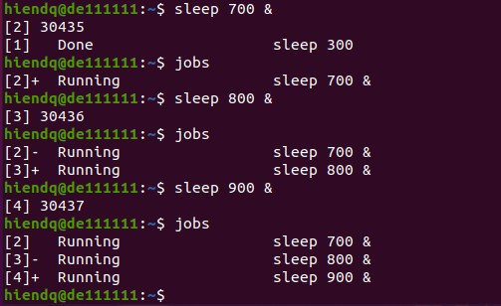

* + If we want to bring job [4] (#sleep 900 &) from background to foreground, we use the command #*fg %4*

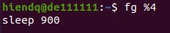

* + Press Ctrl + C to kill this process and check the remaining jobs

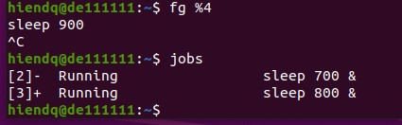

1. KILL process
   * + Now, we run 4 processes these are #*sleep 1000 &, #sleep 2000 &, #sleep 3000 &* and *#sleep 4000 &.* Checking all these jobs by using the command *#jobs.*

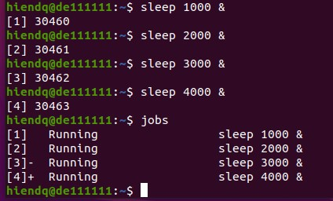

* + - Using the command #*kill -L* to list all sig numbers on the system.

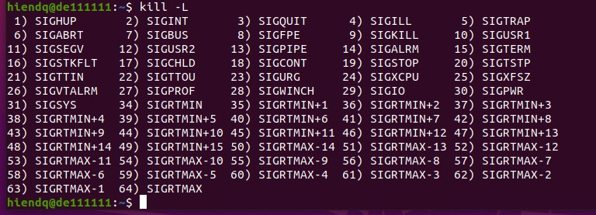

* + - Among them, 15 is used for sigterm (Signal Termination). We will use this number to kill one of the four processes on the system. Using the command #*ps ax | grep sleep* to check them first.

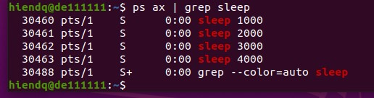

* + - Using the command #*kill -15 30460* to kill the first one on the list.

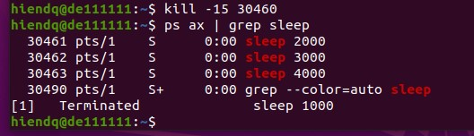

* + - We could use sig number 19 to stop a signal and 18 to continue a signal. For example:

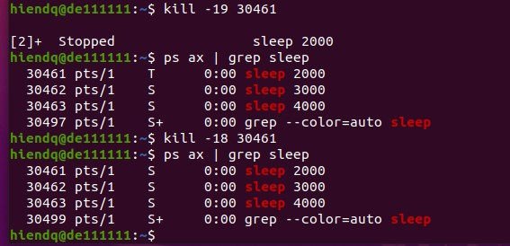

1. To check the number of cores as well as processors on your system, you should use the command #CPU get numberofcores,numberoflogicalprocessors (in Windows)



1. As we know, an application has one or more processes. One process has one or more threads. To check it, open Task manager and ProcessExplorer to examine the application Google Chrome.

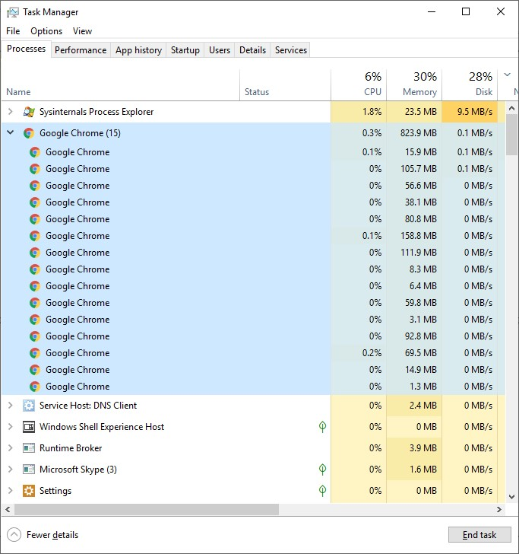

1. In this instance, the application Google Chrome has 15 processes. If we want to know what threads reside in a specific process, we should use ProcessExplorer. Just double click on a process to see the list of threads.

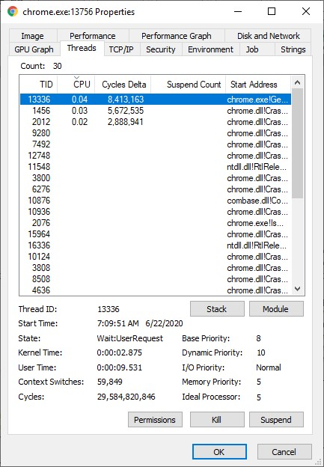

#### 2.3.1 Questions

1. Which of these statements about Batch service in Mainframe OS are true?
   1. CPU is often idle, all jobs are kept on a disk
   2. Process routine job without interactive user present
   3. The OS always residents in memory and transfer control automatically from one job to the next in the sequence requested jobs
   4. None of the other
2. Which of these statements about the advantages of Virtual Machines are true?
   1. Do not disrupt the normal system operation, completely protecting system resources, and solving system compatibility system
   2. Do not disrupt the normal system operation, completely protecting system resources, and keep track of which virtual machine has been assigned which resource
   3. Saving a layer mapping, do not disrupt the normal system operation, and completely protecting system resources
   4. Allocate all disks, completely protecting system resources, and solving system compatibility system
3. An operating system uses shortest remaining time first scheduling algorithm for preemptive scheduling of processes. Consider the following set of processes with their arrival times and CPU burst times (in milliseconds). The average waiting time (in ms) of the processes is _____

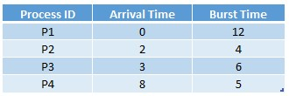 a) 4.5

* 1. 5.0
  2. 5.5
  3. 6.5

1. An operating system uses shortest remaining time first scheduling algorithm for preemptive scheduling of processes. Consider the following set of processes with their arrival times and CPU burst times (in milliseconds). The average waiting time (in ms) of the processes is _____

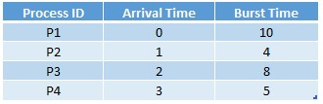

P1: 9 p1:17, p2:0, p3: 8 p4: 2

|  |  |  |  |  |  |
| --- | --- | --- | --- | --- | --- |
| P1 | P2 | P4 | P3 | P1 |  |

0 1 5 10 18 27

* 1. 6.75
  2. 6.5
  3. 1.5
  4. 5.25

1. Consider the following processes with the arrival time and the length of the CPU burst given in milliseconds. The scheduling algorithm used is preemptive shortest remaining time first. The average turn around time of these processes is _____ milliseconds.

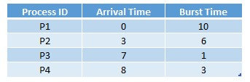

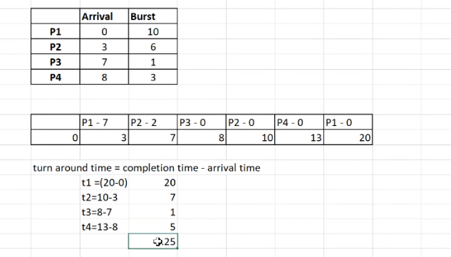

turn around time = completion time – arrival time

* 1. 8.25
  2. 3
  3. 5
  4. 6

1. Consider the following processes with the arrival time and the length of the CPU burst given in milliseconds. The scheduling algorithm used is preemptive shortest remaining time first. The average turn around time of these processes is _____ milliseconds.

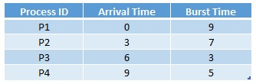

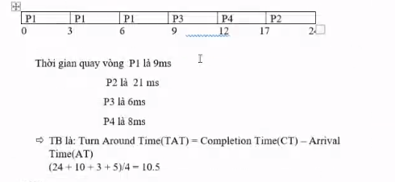

(sửa chỗ turn around time = (9+21+6+8)/4=11)

a) 4.5

* 1. 5
  2. 6
  3. 11

1. Consider the following processes with the arrival time and the length of the CPU burst given in milliseconds. The scheduling algorithm used is preemptive shortest remaining time first. The average turn around time of these processes is _____ milliseconds.

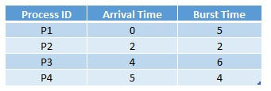

a) 2

* 1. 2.75
  2. 4.25
  3. 7

1. Which the following statement is not true about scheduling algorithms?
   1. FCFS scheduling can be either preemptive or non-preemptive
   2. SJF scheduling can be either preemptive or non-preemptive
   3. Priority scheduling can be either preemptive or non-preemptive
   4. Equal-priority processes are scheduled in FCFS order
2. Which the following statement is not true about priority scheduling algorithm?
   1. A priority is associated with each process, and the CPU is allocated to the process with the highest priority
   2. Equal-priority processes are scheduled in FCFS order
   3. Priority scheduling can be either preemptive or non-preemptive
   4. A preemptive priority scheduling algorithm will preempt the CPU if the priority of the newly arrived process is lower than the priority of the currently running process
3. Which the following statement is not a problem with priority scheduling?
   1. A major problem with priority scheduling algorithms is indefinite blocking or starvation.
   2. A process that is ready to run but waiting for the CPU can be considered blocked.
   3. A priority scheduling algorithm can leave some low priority processes waiting indefinitely.
   4. Priority scheduling can be either preemptive or non-preemptive.
4. Consider the set of processes with arrival time (in milliseconds), CPU burst time (in milliseconds) and priority (0 is the highest priority) shown below. None of the processes have I/O burst time. The average waiting time (in milliseconds) of all the processes using preemptive priority scheduling algorithms is _____

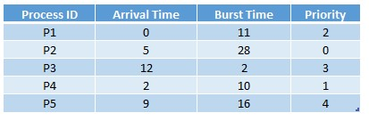 a) 29

* 1. 30
  2. 31
  3. 32

1. Consider the set of processes with arrival time (in milliseconds), CPU burst time (in milliseconds) and priority (0 is the highest priority) shown below. None of the processes have I/O burst time. The average waiting time (in milliseconds) of all the processes using preemptive priority scheduling algorithms is _____

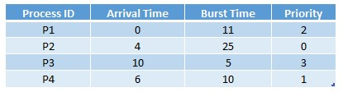 a) 5

* 1. 10.25
  2. 12.75
  3. 23.5

1. Consider the set of processes with arrival time (in milliseconds), CPU burst time (in milliseconds), and priority shown below (Higher number represents higher priority). If the CPU scheduling policy is priority non-preemptive, the average waiting time is _____

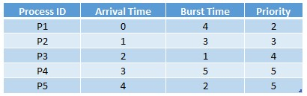 a) 2.2

* 1. 3
  2. 3.8
  3. 5.2

1. Consider the set of processes with arrival time (in milliseconds), CPU burst time (in milliseconds), and priority shown below (Higher number represents higher priority). If the CPU scheduling policy is priority non-preemptive, the average turnaround time is _____

 a) 2.2

* 1. 3.8
  2. 5.2
  3. 8.2

1. Consider the following set of processes that arrive at time 0, with the length of the CPU burst given in milliseconsd and time quantum taken as 4 milliseconds for Round-Robin Scheduling. The average turnaround time is _____

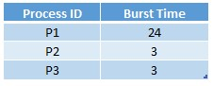

* 1. 5.66
  2. 8
  3. 2.22
  4. 10

1. Consider the set of 5 processes whose arrival time and burst time are given below. If the CPU scheduling policy is Round Robin with time quantum 2 units, the average waiting time is _____

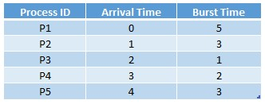

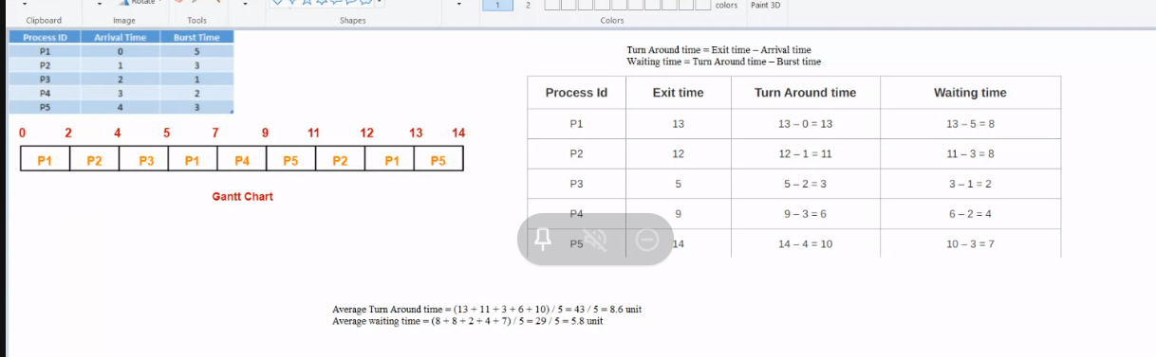

a) 5.5

* 1. 6.8
  2. 7.6
  3. 5.8

1. Consider the set of 5 processes whose arrival time and burst time are given below. If the CPU scheduling policy is Round Robin with time quantum 2 units, the average turnaround time is _____



* 1. 5.6
  2. 6.6
  3. 7.6
  4. 8.6

1. Which the following statement is not true about multilevel queue scheduling algorithm?
   1. The processes are permanently assigned to one queue, generally based on some property of the process, such as memory size, process priority, or process type.
   2. Each queue has its own scheduling algorithm
   3. Separate queues might be used for foreground and background processes
   4. The foreground queue must be scheduled by an RR algorithm while the background queue is scheduled by an FCFS algorithm
2. Which the following statement is not true about multilevel Feedback-Queue scheduling algorithm?
   1. The idea is to separate processes according to the characteristics of their CPU bursts.
   2. If a process uses too much CPU time, it will be moved to a lower-priority queue
   3. This scheme leaves I/O-bound and interactive processes in the higher-priority queues.
   4. A process that waits too long in a lower-priority queue can not be moved to a higher-priority queue.
3. Consider a set of n tasks with known runtimes r1, r2, ..., rn to be run on a uniprocessor machine. Which of the following processor scheduling algorithms will result in the maximum throughput?

a) Shortest-Job-First

* 1. Round-Robin
  2. Highest-Response-Ratio-Next
  3. First-Come-First-Serve

1. Which of the following scheduling algorithms is non-preemptive?
   1. Round-Robin
   2. Multilvel Queue Scheduling
   3. Multilevel Queue Scheduling with Feedback
   4. First Come First Serve
2. Which of the following statements are true?
   * + I. Shortest remaining time first (SRTF)(thời gian còn lại ngắn nhất) scheduling may cause starvation
     + II. Pre-emptive(ưu tiên) scheduling may cause starvation
     + III. Round Robin is better than FCFS in terms of response time (về thời gian phản hồi)

a) I only

* 1. I and III only
  2. II and III only
  3. I, II and III

1. Consider the 3 processes, P1, P2 and P3 shown in the table. The completion order of the 3 processes under the policies FCFS and RR2 (Round-Robin scheduling with CPU quantum of 2 time units) are _____

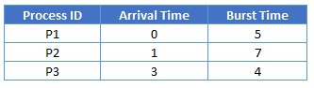

|  |  |  |  |
| --- | --- | --- | --- |
| P1 | P1 | P3 | P2 |

0 2 5 9 16

* 1. FCFS: P1, P2, P3; RR2: P1, P3, P2
  2. FCFS: P1, P2, P3; RR2: P1, P2, P3
  3. FCFS: P1, P3, P2; RR2: P1, P3, P2
  4. FCFS: P1, P3, P2; RR2: P1, P2, P3

1. A scheduling algorithm assigns priority proportional to the waiting time of a process. Every process starts with priority zero (the lowest priority). The scheduler reevaluates the process priorities every T time units and decides the next process to schedule. Which one of the following is TRUE if the processes have no I/O operations and all arrive at time zero?
   1. This algorithm is equivalent to the round-robin algorithm
   2. This algorithm is equivalent to the FCFS algorithm.
   3. This algorithm is equivalent to the SJF algorithm
   4. This algorithm is equivalent to the Shortest-remaining-time-first algorithm
2. Which is a wrong statement about the quantum used in Round Robin algorithm?
   1. A reasonable value of quantum is around 20 - 50 ms
   2. If the quantum is very large, RR is essentially FCFS
   3. The quantum is very small, the CPU efficiency is reduced
   4. None of the others
3. Which of the following process state transitions are illegal?
   1. Blocked -> Running
   2. Running -> Ready
   3. Blocked -> Ready
   4. Ready -> Running
4. Which of the following process state transitions are illegal?
   1. Ready-> Running
   2. Running -> Ready
   3. Running -> Terminated
   4. Waiting -> Running
5. Which is the correct description of transitions between process states below?

1: Running -> Blocked

2: Running -> Ready

3: Ready -> Running 4: Block -> Ready

* 1. 1: Process blocks for input; 2: Scheduler picks another process; 3: Scheduler picks this process; 4: Input becomes available
  2. 1: Process blocks for input; 2: Scheduler picks this process; 3: Scheduler picks another process; 4: Input becomes available
  3. 1: Process blocks for input; 2: Input becomes available; 3: Scheduler picks another process; 4: Scheduler picks this process
  4. 1: Process blocks for input; 2: Input becomes available; 3: Scheduler picks this process; 4: Scheduler picks another process

1. Assume that four jobs A-D require the CPU cycles listed below. Using the RoundRobin algorithm with time slide equaling 4, the waiting time of all process is ______

.

Arrival time: 4 1 0 2

Job: A B C D

CPU cycle: 5 2 6 4

* 1. 42
  2. 6.25
  3. 10.5
  4. 25

1. Assume that four jobs A-D require the CPU cycles listed below. Using the Shortest Job First algorithm, the _____ job is run first.

Arrival time: 4 1 0 2

Job: A B C D

CPU cycle: 5 2 6 4

* 1. A
  2. B
  3. C
  4. D

1. Assume that four jobs A-D require the CPU cycles listed below. Using the Round-Robin algorithm with time slide equaling 4, the average of turnaround time of one process is _____.

Arrival time: 4 1 0 2

Job: A B C D

CPU cycle: 5 2 6 4

* 1. 42
  2. 6.25
  3. 25
  4. 10.5

1. Process is _____
   1. Program in high level language kept on disk
   2. Program in low level language kept on RAM
   3. Contents of main memory
   4. A program in execution
2. Fork is _____
   1. The dispatching of a task
   2. The creation of a new job
   3. The creation of a new process
   4. Increasing the priority of a task
3. The unit of dispatching is usually referred as _____
   1. Multiprogramming
   2. Security policy
   3. Problem
   4. Thread
4. Communication in client server systems may uses Sockets and _____
   1. Process Control Block (PCB)
   2. Remote Procedure Calls (RPCs)
   3. Kernel mode
   4. Registers
5. When a thread needs to wait for an event it will _____
   1. Block
   2. Execute
   3. Terminate
   4. Update
6. A Process Control Block (PCB) does not contain which of the following:
   1. Bootstrap program
   2. Data
   3. Stack
   4. Code
7. What Linux command is used to list files and folders on a disk?
   1. mkdir
   2. cd
   3. ps
   4. ls
8. The address of the next instruction to be executed by the current process is provided by the _____
   1. CPU registers
   2. Instruction register
   3. Program counter
   4. Stack pointer
9. What Linux command is used to change attribute of files?
   1. chdir
   2. cd
   3. chown
   4. chmod
10. Assume that Process A with 4 threads, Process B with 3 threads are running local scheduling, 50-msec for process quantum and threads run 10-msec/CPU burst.

Which of possible scheduling for user level threads are true? a) A1, A2, B1, B2, B3, A1, A2, ...

* 1. A1, B1, A2, B2, A3, B3, A4, B1, ...
  2. B1, A1, B2, A2, B3, A3, B1, A4, ...
  3. B1, B2, B3, B1, B2, A1, A2, A3, A4, A1, B1, B2, ...

1. Consider the following set of processes, the length of the CPU burst time given in milliseconds. Assuming these processes being scheduled with the SJF scheduling algorithm. The waiting time for process P1 is ____

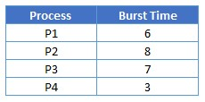

* 1. 0 ms
  2. 9 ms
  3. 16 ms
  4. 3 ms

1. Consider a set of 5 processes whose arrival time (in ms), CPU time needed (in ms) and the priority (smaller the number, higher the priority) are given below. If the CPU scheduling policy FCFS, then the average waiting time will be _____

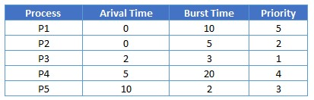

* 1. 12.8 ms
  2. 8 ms
  3. 6 ms
  4. 10 ms

1. To execute a system call in user mode, what are the steps to do in order?
   * + 1. Put the argument of the system call on the stack.
     + 2. The system call is located and executed.
     + 3. The interrupt occurs to switch from user mode to kernel mode.
     + 4. After finished, the interrupt occurs again to switch to user mode. ✓ 5. The control is returned to the system call.
   1. 1, 3, 2, 4, 5
   2. 1, 3, 4, 2, 5
   3. 1, 2, 3, 4, 5
   4. 1, 2, 4, 3, 5
2. The group of Linux OS commands are interpreted by _____
   1. Shell
   2. Compiler
   3. Command
   4. Script
3. Win32 OS does not support the **link** system call
   1. True
   2. False
4. Linux OS support the **kill** signal.
   1. True
   2. False
5. Consider the following set of processes, the length of the CPU burst time given in milliseconds. Assuming these processes being scheduled with the SJF scheduling algorithm. The average waiting time for all processes is ____



* 1. 6 ms
  2. 7 ms
  3. 4.25 ms
  4. 4 ms

1. Assume that four jobs A-D require the CPU cycles listed below. Using the Shortest Job First algorithm, the average waiting time for all processes is _____.

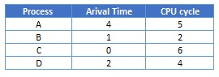

* 1. 1.25 ms
  2. 4.25 ms
  3. 6 ms
  4. 3.75 ms

1. The systems which allow only one process execution at a time, are called _____
   1. uniprogramming systems
   2. uniprocessing systems
   3. unitasking systems
   4. none of the mentioned
2. In Unix, Which system call creates the new process?
   1. fork
   2. create
   3. new
   4. made
3. A process can be terminated due to _____
   1. normal exit
   2. fatal error
   3. killed by another process
   4. all of the mentioned
4. What is the ready state of a process?
   1. when process is scheduled to run after some execution
   2. when process is unable to run until some task has been completed
   3. when process is using the CPU
   4. When process is waiting for an I/O event
5. What is interprocess communication?
   1. communication within the process
   2. communication between two process
   3. communication between two threads of same process
   4. none of the mentioned
6. A process stack does not contain _____
   1. Function parameters
   2. Local variables
   3. Return addresses
   4. PID of child process
7. A Process Control Block(PCB) does not contain which of the following?
   1. Code
   2. Stack
   3. Bootstrap program
   4. Data
8. The state of a process is defined by _____
   1. the final activity of the process
   2. the activity just executed by the process
   3. the activity to next be executed by the process
   4. the current activity of the process
9. Which of the following is not the state of a process?
   1. New
   2. Old
   3. Waiting
   4. Running
10. The entry of all the PCBs of the current processes is in _____
    1. Process Register
    2. Program Counter
    3. Process Table
    4. Process Unit
11. _____ switches from user mode to kernel mode and starts the operating system.
    1. The system call
    2. The TRAP instruction
    3. The User program
    4. The Admin program
12. _____ switches from user mode to kernel mode and starts the operating system. a) The system call
    1. The TRAP instruction
    2. The User program
    3. The Admin program
13. _____ switches from user mode to kernel mode and starts the operating system. a) The system call
    1. The TRAP instruction
    2. The User program
    3. The Admin program
14. Which of these statements about the Shell is not true?
    1. Shell is a part of the operating system.
    2. Shell is the main interface between a user at Terminal and the operating system.
    3. Many shells exist, including sh, csh, ksh and bash.
    4. When any user logs in, a shell is started up.
15. A process is running in user mode and calls a system service, it has to execute _____ , _____ and to transfer control to the OS (choose 2) a) an interrupt
    1. a trap instruction
    2. a switching
    3. a function call
16. Which of these statements about Layered System are not true? (Choose 2)
    1. Bottom layer is the user interface
    2. The highest layer is hardware
    3. Layers are selected so that each one uses functions, operations and services of only lower-level layers
    4. The highest layer is the user interface
17. Assume that four jobs A-D arrived Ready list in order at the same time at 0, require the CPU cycles listed below and were not blocked during running time. Using the Round-Robin algorithm with quantum time 4ms, the average waiting time of all process is ______.

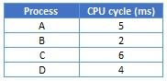

* 1. 34 ms
  2. 10.5 ms
  3. 11.5 ms
  4. 8.75 ms

1. Scheduling of threads are done by _____
   1. operating system
   2. input
   3. output
   4. memory
2. Using Priority Scheduling algorithm, find the average waiting time for the following set of processes given with their priorities (1 is the highest priority) in the order.

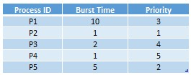

* 1. 8 milliseconds
  2. 7.75 milliseconds
  3. 3 milliseconds
  4. 8.2 milliseconds

1. A process is selected from the _____ queue by the _____ scheduler, to be executed. a) ready, short term
   1. blocked, short term
   2. wait, long term
   3. ready, long term

70)

# CHAPTER 3. DEADLOCKS

## 3.1 Purposes

## 3.2 Requirements

## 3.3 Practice and Questions

#### 3.3.1 Practice

#### 3.3.2 Questions

1. With deadlock detection, requested resources are granted to _____
   1. Processes
   2. Resources
   3. Programs
   4. Users
2. Deadlock prevention strategies are very _____
   1. Conservative
   2. Straight
   3. Complex
   4. Simple
3. All deadlocks involve conflicting needs for _____
   1. Resources
   2. Users
   3. Computers
   4. Programs
4. No preemption means that a resource is released as _____
   1. Terminated
   2. Non Voluntarily
   3. Interrupted
   4. Voluntarily
5. Deadlock avoidance requires knowledge of future _____ : thuật toán banker’s algorithm
   1. Process
   2. Resource
   3. Program
   4. Application
6. A possibility of deadlock can occur _____
   1. If a system is in safe state
   2. If a system is in unsafe state
   3. If a system is in instable state
   4. None of the others
7. Consider the following snapshot of a system. Choose the correct statement in progress of process using the banker’s algorithm.

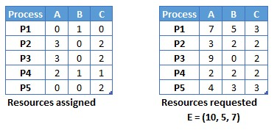

* 1. P1, P2, P3, P4, P5
  2. P2, P4, P5, P1
  3. P5, P4, P3, P2, P1
  4. P2, P4, P5, P1, P3

1. The Banker’s algorithm is used _____
   1. To solve deadlock
   2. To rectify deadlock
   3. To detect deadlock
   4. To prevent deadlock
2. A system has 12 magnetic tape drives and 3 processes: P0, P1 and P2 as following table.

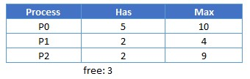

Which of the following sequence is a safe sequence?

* 1. P2, P0, P1
  2. P2, P1, P0
  3. P1, P2, P0
  4. P1, P0, P2

1. What is Software proposal in the solution of Mutual exclusion with Busy waiting?
   1. Lock Variables
   2. Strict Alternation
   3. Peterson’s Solution
   4. All of the others
2. The set of pages that a process is currently using is called as _________.
   1. Working set
   2. Paging table
   3. Preparing
   4. Process table
3. If there are 1024 pages and the page size is 4096 bytes, what is the length of logical address?
   1. 17 bits
   2. 18 bits
   3. 21 bits
   4. 22 bits
4. Which of the following reason by which Windows or Unix do not use to prevent deadlock in Ostrich algorithm?
   1. Deadlock occurs very rarely
   2. Difficult to detect deadlock
   3. Cost of prevention is high
   4. It’s easy to get deadlock in Windows and Unix systems.
5. Which process could run first if the system uses Banker’s algorithm?

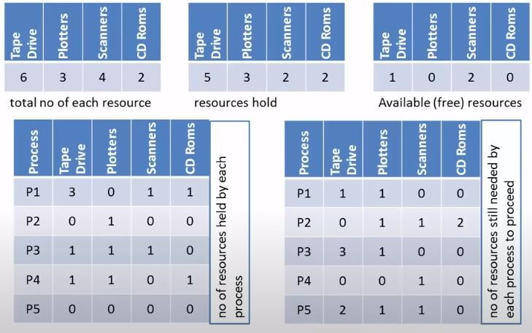a) P1

* 1. P2
  2. P3
  3. P4

1. Which process could run next if the system uses Banker’s algorithm for multiple resources?

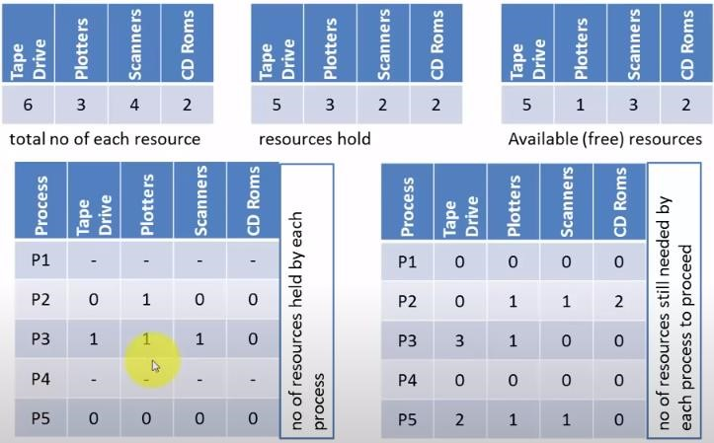

* 1. P1
  2. P2
  3. P3
  4. P5

1. Which of the following reason causes deadlock in the system?

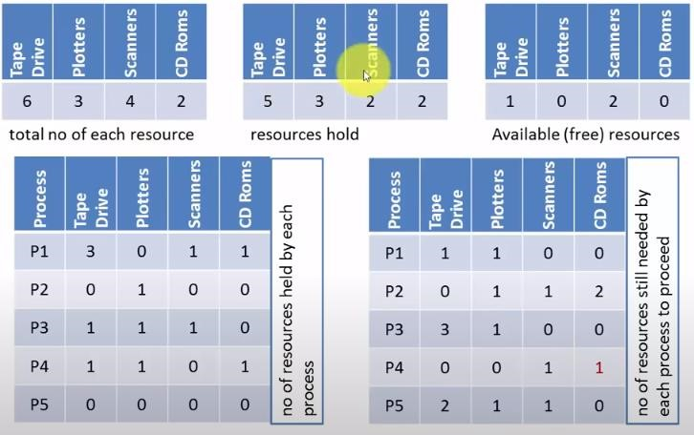

* 1. The free resources are not enough for processes P1, P2
  2. The free resources are not enough for processes P1, P2, P3
  3. The free resources are not enough for processes P1, P2, P3, P4
  4. The free resources are not enough for processes P1, P2, P3, P4, P5

1. Which recovery method is crudest but simplest way to break a deadock?
   1. Take a resource from some other process
   2. Recovery through rollback
   3. Recovery through preemption
   4. Killing processes
2. Is the following system in safe state?

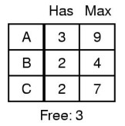

* 1. Yes
  2. No

1. Is the following system in safe state?

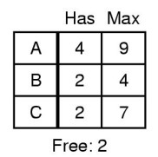

* 1. Yes
  2. No

1. Is the following system in safe state?

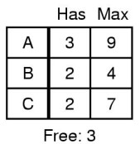

* 1. Yes
  2. No

1. Is the following system in safe state?

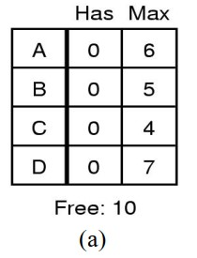

* 1. Yes
  2. No

1. Is the following system in safe state?

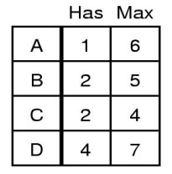

* 1. Yes
  2. No

1. What is a reusable resource?
   1. that can be used by one process at a time and is not depleted by that use
   2. that can be used by more than one process at a time
   3. that can be shared between various threads
   4. none of the mentioned
2. Which of the following condition is required for a deadlock to be possible?
   1. mutual exclusion (loại trừ lẫn nhau) ng này dung thì kia ko dùng
   2. a process may hold allocated resources while awaiting assignment of other resources
   3. no resource can be forcibly removed from a process holding it
   4. all of the others
3. The circular wait condition can be prevented by ____________
   1. defining a linear ordering of resource types
   2. using thread
   3. using pipes
   4. all of the mentioned
4. Which one of the following is the deadlock avoidance algorithm?
   1. banker’s algorithm
   2. round-robin algorithm
   3. elevator algorithm
   4. karn’s algorithm
5. What is the drawback of banker’s algorithm?
   1. in advance processes rarely know how much resource they will need
   2. the number of processes changes as time progresses
   3. resource once available can disappear
   4. all of the mentioned
6. For an effective operating system, when to check for deadlock?
   1. every time a resource request is made
   2. at fixed time intervals
   3. every time a resource request is made at fixed time intervals
   4. none of the mentioned
7. A problem encountered in multitasking when a process is perpetually denied necessary resources is called ____________ a) deadlock
   1. starvation
   2. inversion
   3. aging
8. Which one of the following is a visual ( mathematical ) way to determine the deadlock occurrence?
   1. resource allocation graph
   2. starvation graph
   3. inversion graph
   4. none of the mentioned
9. To avoid deadlock ____________
   1. there must be a fixed number of resources to allocate
   2. resource allocation must be done only once
   3. all deadlocked processes must be aborted
   4. inversion technique can be used
10. Each request requires that the system consider the _____________ to decide whether the current request can be satisfied or must wait to avoid a future possible deadlock. a) resources currently available
    1. processes that have previously been in the system
    2. resources currently allocated to each process
    3. future requests and releases of each process
11. Given a priori information about the ________ number of resources of each type that maybe requested for each process, it is possible to construct an algorithm that ensures that the system will never enter a deadlock state. a) minimum
    1. average
    2. maximum
    3. approximate
12. A deadlock avoidance algorithm dynamically examines the __________ to ensure that a circular wait condition can never exist. a) resource allocation state
    1. system storage state
    2. operating system
    3. resources
13. A state is safe, if _____
    1. the system does not crash due to deadlock occurrence (nhiều lí do khác, không chắc là do deadlock)
    2. the system can allocate resources to each process in some order and still avoid a deadlock
    3. the state keeps the system protected and safe
    4. all of the mentioned
14. A system is in a safe state only if there exists a _____
    1. safe allocation (phân bổ an toàn)
    2. safe resource (tài nguyên an toàn)
    3. safe sequence (trình tự an toàn: cấp ai trước cấp ai sau)
    4. safe device (thiết bị an toàn: chuột máy tính bàn phím…)
15. A set of processes is deadlock if _____
    1. each process is blocked and will remain so forever
    2. each process is terminated
    3. all processes are trying to kill each other
    4. all processes are killed by the user
16. What is the hardware proposal in the solution of Mutual exclusion with Busy waiting? (giải pháp phần cứng)
    1. Lock Variables. (giải pháp phần mềm)
    2. Disable interrupt
    3. Strict Alternation.
    4. Peterson's Solution.
17. If there are 1024 pages and the page size is 8192 bytes, what is the length of logical address?
    1. 23 bits
    2. 10 bits
    3. 18 bits
    4. 32 bits
18. Which strategies (chiến lược) are designed for speeding up Paging? (Choose 2)
    1. Page table is loaded into main memory.
    2. Using TLB. Translation Lookaside Buffer
    3. Page table is loaded into disk.
    4. Page table is divided into several levels.
19. Suppose that a computer with 16 bits virtual address use a single level page table and 15 bits physical memory address is given by the following page table. Which is the physical address that the MMU will map with the virtual address 1000 0000 0010 0100 onto?

4 bits đầu tiên của virtual address là

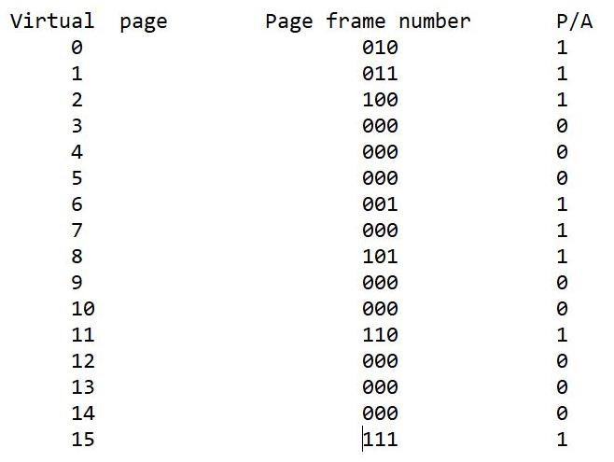

* 1. 101 0000 0010 0100
  2. 011 0000 0100 0100
  3. 110 0000 0100 0000
  4. DISK

1. Consider that a TLB (Translation Lookaside Buffer) is given by the following table. What will be happened if the instruction is trying to write on the virtual page number 130th?

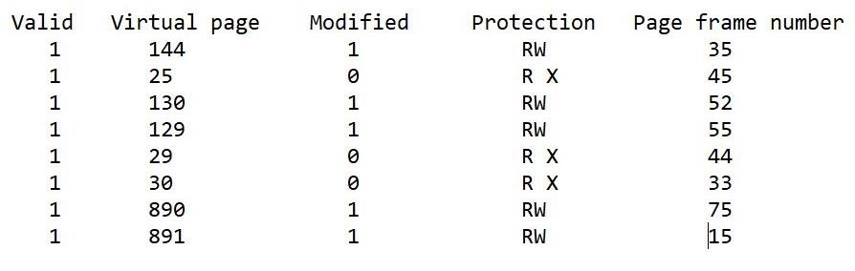

* 1. A protection fault is generated
  2. A page fault occurs
  3. The page frame 52 will be deleted
  4. The page frame 52 will be modified

1. If all page frames are initially empty, and a process is allocated 3 page frames in real memory and references its pages in the order 1 2 3 2 4 5 2 3 2 4 1 and the page replacement is FIFO, the total number of page faults caused by the process will be _____ a) 8
   1. 11
   2. 9
   3. 10
2. Deadlock prevention is a set of methods _____
   1. to ensure that all of the necessary conditions do not hold
   2. to ensure that at least one of the necessary conditions cannot hold
   3. to decide if the requested resources for a process have to be given or not
   4. to avoid deadlock

45)

# CHAPTER 4. MEMORY MANAGEMENT

## 4.1 Purposes

## 4.2 Requirements

## 4.3 Practice and Questions

#### 4.3.1 Practice

#### 4.3.2 Questions

1. A computer has 1.5 GB of memory, with OS taking 730 MB and each user program also taking up 350 MB with an 50% average I/O wait. What is the percentage of CPU utilization? a) 75%
   1. 93,75%
   2. 79,69%
   3. 50%
2. The page table for each process maintains _____
   1. The frame location for each page of the process
   2. The page location for each frame of the process
   3. The physical memory location of the process
   4. None of the others
3. Consider a swapping system in which memory consists of the following hole sizes in memory order: 10 KB, 4 KB, 20 KB, 18KB, 7 KB, 9KB, 12 KB, and 15 KB. Which hole is take for successive segment requests of 12 KB, 10KB, 9KB for first fit?
   1. 20 KB, 10KB, 18KB
   2. 12KB, 10 KB, 9KB
   3. 20KB, 18KB, 9KB
   4. 20KB, 18KB, 15 KB
4. What is not correct about contiguous allocation of files?
   1. It does not cause disk fragmentation **Đ**
   2. It is simple to implement **Đ**
   3. It leads to excellent read performance <- S
   4. It is widely used on CD-ROMs **Đ**
5. What are the allocation methods of disk blocks for files?
   1. Contiguous allocation
   2. Linked allocation
   3. Indexed allocation
   4. All of the others
6. Which the following statement is not true about RAM and ROM?
   1. RAM stands for Random Access Memory. ROM stands for Read Only Memory.
   2. RAM is a read-write memory. ROM is read only memory.
   3. RAM is used to store the data that has to be currently processed by CPU temporarily. ROM is stores the instructions required during bootstrap of the computer.
   4. RAM is a non-volatile memory. ROM is a volatile memory. ( <- ngược lại mới đúng )
7. Which the following order is the correct order of the hierarchical arrangement of storage in current computer architectures?
   1. Register, Cache, Main memory, Local secondary storage, Remote secondary storage.
   2. Register, Main memory, Cache, Local secondary storage, Remote secondary storage.
   3. Register, Cache, Local secondary storage, Main memory, Remote secondary storage.
   4. Register, Cache, Local secondary storage, Remote secondary storage, Main memory.
8. The algorithm to remove and place new contents into the cache is called _____ a) Swapping
   1. Updation
   2. Renewal algorithm
   3. Replacement algorithm
9. In the context of memory management, which technique allows to load a new process to memory by moving another one out? a) Swapping
   1. Paging (phân trang, các page number)
   2. Partitioning (phân vùng :chia các ổ đĩa, chia ram ra nhiều )
   3. Fragmentation (phân mảnh)
10. Consider a swapping system in which memory consists of the following hole sizes in memory order: 10 KB, 4 KB, 20 KB, 18 KB, 7 KB, 9 KB, 12 KB and 15 KB. Which hole is take for successive segment requests of 12 KB, 10 KB, 9 KB for best fit?
    1. 12 KB, 10 KB, 9 KB
    2. 20 KB, 10 KB, 18 KB
    3. 20 KB, 18 KB, 15 KB
    4. 20 KB, 18 KB, 9 KB
11. Consider a swapping system in which memory consists of the following hole sizes in memory order: 10 KB, 4 KB, 20 KB, 18 KB, 7 KB, 9 KB, 12 KB and 15 KB. Which hole is take for successive segment requests of 12 KB, 10 KB, 9 KB for worst fit?
    1. 12 KB, 10 KB, 9 KB
    2. 20 KB, 10 KB, 18 KB
    3. 20 KB, 18 KB, 9 KB
    4. 20 KB, 18 KB, 15 KB
12. Consider a swapping system in which the memory consists of the following hole sizes: 10 KB, 4 KB, 20 KB, 15 KB, 9 KB. Assume worst fit algorithm is used. Which holes are taken for successive segment requests of 8 KB, 12 KB, 10 KB? a) 20 KB, 15 KB, 12 KB
    1. 10 KB, 15 KB, 20 KB
    2. 9 KB, 15 KB, 10 KB
    3. 10 KB, 20 KB, 15 KB
13. Consider a swapping system in which the memory consists of the following hole sizes: 10 KB, 4 KB, 20 KB, 15 KB, 9 KB. Assume best fit algorithm is used. Which holes are taken for successive segment requests of 8 KB, 12 KB, 10 KB? a) 20 KB, 15 KB, 10 KB
    1. 10 KB, 15 KB, 20 KB
    2. 10 KB, 20 KB, 15 KB
    3. 9 KB, 15 KB, 10 KB
14. Consider a swapping system in which the memory consists of the following hole sizes: 10 KB, 4 KB, 20 KB, 15 KB, 9 KB. Assume first fit algorithm is used. Which holes are taken for successive segment requests of 8 KB, 12 KB, 10 KB? a) 20 KB, 15 KB, 10 KB
    1. 10 KB, 15 KB, 20 KB
    2. 9 KB, 15 KB, 10 KB
    3. 10 KB, 20 KB, 15 KB
15. In terms of storage utilization the best method of dynamic storage allocation is _____ a) Best fit
    1. Worst fit
    2. First fit
    3. Next fit
16. Consider a swapping system in which the memory consists of the following hole sizes: 10 KB, 5 KB, 15 KB, 20 KB, 8 KB. Assume first fit algorithm is used. Which holes are taken for successive segment requests of 8 KB, 15 KB, 10 KB? a) 8 KB, 15 KB, 10 KB
    1. 20 KB, 15 KB, 10 KB
    2. 8 KB, 15 KB, 20 KB
    3. 10 KB, 15 KB, 20 KB
17. Consider a swapping system in which the memory consists of the following hole sizes: 10 KB, 5 KB, 15 KB, 20 KB, 8 KB. Assume best fit algorithm is used. Which holes are taken for successive segment requests of 8 KB, 15 KB, 10 KB? a) 20 KB, 15 KB, 10 KB
    1. 8 KB, 15 KB, 20 KB
    2. 10 KB, 15 KB, 20 KB
    3. 8 KB, 15 KB, 10 KB
18. Consider a swapping system in which the memory consists of the following hole sizes: 10 KB, 5 KB, 15 KB, 20 KB, 8 KB. Assume worst fit algorithm is used. Which holes are taken for successive segment requests of 8 KB, 15 KB, 10 KB? a) 8 KB, 15 KB, 10 KB
    1. 8 KB, 15 KB, 20 KB
    2. 10 KB, 15 KB, 20 KB
    3. 20 KB, 15 KB, 12 KB
19. Consider the following pseudo code fragment
    * + Assuming that the process linked list and the hole linked list are same data structure that are declared in global scope and contain the progressed data
      + IF the specific process is allocated then
      + That process element is removed from process list
      + Next, it is attached at the end of the hole list
      + The hole list is sorted
      + End if
      + If finding the memory is large enough to allocate to process
      + While (!holeList)
      + If(holeList.size equals the needed memory size)
      + Allocate the memory
      + Break
      + End if
      + End while
      + End if

Which solution is described in allocation memory for process in “Memory

Management with Linked List” concepts?

* 1. Quickfit
  2. Bestfit
  3. Worstfit
  4. Mergefit

1. What is compaction? (nén)
   1. Technique for overcoming fatal error
   2. Technique for overcoming internal fragmentation
   3. Paging technique
   4. Technique for overcoming external fragmentation
2. Operating System maintains the page table for _____
   1. each address
   2. each instruction (chỉ thị lệnh)
   3. each thread (tiểu trình)
   4. each process
3. Consider that a TLB (Translation Lookaside Buffer) is given by the following table.

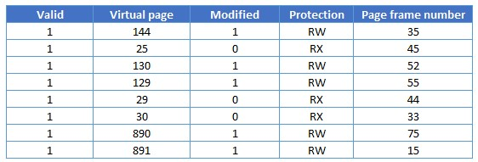

X: Execute

What will be happened if the instruction is trying to write on the virtual page number 25th?

* 1. A protection fault is generated
  2. A page fault occurs
  3. The page frame 45 will be referenced (page hit)
  4. The page frame 45 will be modified (sửa đổi) ko có quyền modified

1. A computer with 32 bits virtual address uses a two-level page table. Virtual addresses are split into a 10 bits top-level page table field (PT1), a 10 bits second-level page table field (PT2), and an offset. How many PT1, PT2, and offset with virtual address 0x00403008?
   1. PT1=1; PT2=3; offset=8
   2. PT1=1; PT2=1; offset=8
   3. PT1=4; PT2=3; offset=8
   4. PT1=4; PT2=1; offset=8
2. For 3 page frames, the following is the reference string: 7 0 1 2 0 3 0 4 2 3 0 3 2 1 2 0 1 7 0 1. How many page faults does the LRU page replacement algorithm produce? a) 12
   1. 13
   2. 14
   3. 15
3. Which following statement is **not correct** about the difference between paging and segmentation?
   1. Paging was invented to get large address space without having to buy more physical memory. Segmentation was invented to allow programs and data to be broken up into logically independent address space and to add sharing and protection.
   2. The programmer does not aware that paging is used while the programmer is aware that segmentation is used.
   3. Procedure and data cannot be distinguished and protected separately when using paging. Procedure and data be distinguished and protected separately when using segmentation.
   4. Change in data or procedure in both paging and segmentation requires compiling entire program.
4. Suppose that a virtual address space of 2^32 bytes, the page size is 2^10 bytes and using page table two levels. If the virtual address is 0x00801005 in hexadecimal, what would be the PT1, PT2, offset in decimal?

10-10-12 : 00000000 10000000 00010000 00000101

PT1 PT2 offset

a) PT1=10; PT2=1; offset=5.

* 1. PT1=2; PT2=8; offset=5.
  2. PT1=10; PT2=8; offset=5.
  3. PT1=2; PT2=1; offset=5.

1. 32-bit virtual address space is mapped to 4 k-byte pages. How many pages can be created? Here, 1k bytes represent 1,024 bytes.

a) 2^4

* 1. 2^10
  2. 2^20
  3. 2^32

1. The _____ swaps processes in and out of the memory.
   1. Memory manager
   2. CPU
   3. CPU manager
   4. User
2. Which of the following is TRUE?
   1. Overlays are used to increase the size of physical memory
   2. Overlays are used to increase the logical address space
   3. When overlays are used, the size of a process is not limited to the size of the physical memory
   4. Overlays are used whenever the physical address space is smaller than the logical address space
3. The address generated by the CPU is referred to as _____
   1. Physical address
   2. Logical address
   3. Neither physical nor logical
   4. Either physical or logical
4. The address loaded into the memory address register of the memory is referred to as

_____

* 1. Physical address
  2. Logical address
  3. Neither physical nor logical
  4. Either physical or logical

1. The run time mapping from virtual to physical addresses is done by a hardware device called the _____
   1. Virtual to physical mapper
   2. Memory management unit
   3. Memory mapping unit
   4. Physical to virtual mapper
2. The _____ time in a swap out of a running process and swap in of a new process into the memory is very high.

a) context – switch

* 1. waiting
  2. execution
  3. all of the mentioned

1. Consider a swapping system in which the memory consists of the following hole sizes: 15 KB, 10 KB, 20 KB, 25 KB, 13 KB. Assume worst fit algorithm is used.

Which holes are taken for successive segment requests of 13 KB, 20 KB, 15 KB?

a) 13 KB, 20 KB, 15 KB

* 1. 13 KB, 20 KB, 25 KB
  2. 15 KB, 20 KB, 25 KB
  3. 25 KB, 20 KB, 15 KB

1. Consider a swapping system in which the memory consists of the following hole sizes: 10 KB, 5 KB, 15 KB, 20 KB, 8 KB. Assume next fit algorithm is used. Which holes are taken for successive segment requests of 8 KB, 15 KB, 10 KB?

a) 8 KB, 15 KB, 10 KB

* 1. 10 KB, 20 KB, 15 KB
  2. 8 KB, 15 KB, 20 KB
  3. 10 KB, 15 KB, 20 KB

1. Suppose that a virtual address space of 2^32 bytes, the page size is 2^12 bytes and using page table two levels. If the virtual address is 0x01C01006 in hexadecimal, what would be the PT1, PT2, offset in decimal?

0000.0001 1100.0000 0001.0000 0000.0110

PT1 PT2 offet

Page size = offset = 12bit -> 32-12 = 20 mỗi cái PT là 10bit

a) PT1=11; PT2=1; offset=6.

* 1. PT1=3; PT2=C; offset=6.
  2. PT1=11; PT2=C; offset=6.
  3. PT1=7; PT2=1; offset=6.

37)

# CHAPTER 5. INPUT/OUTPUT

## 5.1 Purposes

## 5.2 Requirements

## 5.3 Practice and Questions

#### 5.3.1 Practice

#### 5.3.2 Questions

1. DMA is a solution that solves _____
   1. CPU read the disk block from the controller’s buffer a byte or a word at a time by executing a loop, and waste the CPU’s time
   2. CPU read the disk block from the controller’s buffer a byte or a word at a time by executing a loop, and accessing to the system bus independent of the CPU
   3. Accesing to the system bus independent of the CPU, and waste the CPU’s time.
   4. Waste the CPU’s time, and regulating transfers to multiple devices, often concurrently.
2. The I/O devices have no way of seeing memory addresses as they go by on the memory bus, so they have no way of responding to them. Which the type mapping with memory has above disadvantage? a) Memory-Mapped I/O
   1. Memory-Mapped I/O Data Buffer
   2. Memory-Mapped Files
   3. Memory-Mapped Cache
3. A disk queue with requests for I/O blocks on cylinders in orders: 10 171 47 126 4 124 23 8 76. Assume that the disk head is initially at cylinder 50. The ordering cylinder in progress using SSF algorithms will be _____ a) 50 > 47 > 10 > 8 > 4 > 23 > 76 > 124 > 126 > 171
   1. 50 > 10 > 171 > 47 > 126 > 4 > 124 > 23 > 8 > 76
   2. 50 > 76 > 124 > 126 > 171 > 4 > 8 > 10 > 23 > 47
   3. 50 > 47 > 23 > 10 > 8 > 4 > 76 > 124 > 126 > 171
4. Giving a hard disk drive with 255 tracks/Cylinder, 121601 cylinders, 63 sectors/track and 512 bytes/sector. The disk capacity is about _____ a) 953867 GB
   1. 3740 GB
   2. 1 GB
   3. 932 GB
5. Caching _____
   1. holds output for a device
   2. holds the only copy of the data
   3. is fast memory
   4. Holds a copy of the data
6. The time for the disk arm to move the heads to the cylinder containing the desired sector is called _____ a) rotational delay
   1. seek time
   2. disk time
   3. arm time
7. Which the following statement is not a task of device controller?
   1. Device controller can not perform error correction
   2. Device controller converts serial bit stream to block of bytes.
   3. Block of bytes is first assembled bit by bit in buffer inside the controller.
   4. The block has been declared to be error free and then it can be copied to main memory.
8. Which the following statement is not true about I/O port and memory mapped I/O?
   1. I/O port uses different address spaces for memory and I/O devices.
   2. Memory mapped I/O uses different address spaces for memory and I/O devices.
   3. I/O port uses a special class of CPU instructions to access I/O devices.
   4. Memory mapped I/O accesses to the I/O devices using regular instructions.
9. Which the following order is correct about disk read-write using DMA?
   1. CPU programs DMA controller > DMA requests transfer to memory > Data transferred from Disk controller to main memory > Disk controller sends ACK signal back to DMA controller > DMA controller sends ACK signal back to CPU.
   2. CPU programs DMA controller > Data transferred from Disk controller to main memory > DMA requests transfer to memory > Disk controller sends ACK signal back to DMA controller > DMA controller sends ACK signal back to CPU.
   3. CPU programs DMA controller > DMA requests transfer to memory > Disk controller sends ACK signal back to DMA controller > Data transferred from Disk controller to main memory > DMA controller sends ACK signal back to CPU.
   4. CPU programs DMA controller > Data transferred from Disk controller to main memory > Disk controller sends ACK signal back to DMA controller > DMA controller sends ACK signal back to CPU > DMA requests transfer to memory.
10. DMA uses _____
    1. Byte-at-a-time mode and Word-at-a-time mode
    2. Word-at-a-time mode and Block mode
    3. Block mode and Page mode
    4. Page mode and Segmentation mode.
11. Which the following statement is not true about device driver?
    1. I/O devices which are plugged with computer have some specific code for controlling them. This code is called the device driver.
    2. Each device driver normally handles one device type
    3. Generally device driver is not delivered along with the device by device manufacturer.
    4. Device drivers are normally possitioned below the rest of operating system.
12. Which type of buffer mechanism is not used in a computer device?
    1. Buffering in user space
    2. Buffering in kernel followed by user space
    3. Double buffering in kernel space
    4. Tripple buffering in kernel space
13. Consider an imaginary disk with 51 cylinders. A request comes in to read a block on cylinder 11. While the seek to cylinder 11 is in progress, new requests come in for cylinders 1, 36, 16, 34, 9 and 12 in that order. By using the FCFS algorithm, what is the total distance (in cylinders) that the disk arm moves to satisfy all the pending requests? a) 111
    1. 61
    2. 99
    3. 72
14. Consider an imaginary disk with 51 cylinders. A request comes in to read a block on cylinder 11. While the seek to cylinder 11 is in progress, new requests come in for cylinders 1, 36, 16, 34, 9 and 12 in that order. By using the SSTF (SSF) algorithm, what is the total distance (in cylinders) that the disk arm moves to satisfy all the pending requests? a) 111
    1. 61
    2. 99
    3. 72
15. Consider an imaginary disk with 51 cylinders. A request comes in to read a block on cylinder 11. While the seek to cylinder 11 is in progress, new requests come in for cylinders 1, 36, 16, 34, 9 and 12 in that order. By using the LOOK (Elevator) algorithm, what is the total distance (in cylinders) that the disk arm moves to satisfy all the pending requests? a) 111
    1. 61
    2. 99
    3. 60
16. Consider an imaginary disk with 51 cylinders. A request comes in to read a block on cylinder 11. While the seek to cylinder 11 is in progress, new requests come in for cylinders 1, 36, 16, 34, 9 and 12 in that order. By using the C-LOOK algorithm, what is the total distance (in cylinders) that the disk arm moves to satisfy all the pending requests? a) 111
    1. 61
    2. 60
    3. 68
17. Consider an imaginary disk with 51 cylinders. A request comes in to read a block on cylinder 11. While the seek to cylinder 11 is in progress, new requests come in for cylinders 1, 36, 16, 34, 9 and 12 in that order. By using the SCAN algorithm, what is the total distance (in cylinders) that the disk arm moves to satisfy all the pending requests?
    1. 111
    2. 61
    3. 60
    4. 88
18. Consider an imaginary disk with 51 cylinders. A request comes in to read a block on cylinder 11. While the seek to cylinder 11 is in progress, new requests come in for cylinders 1, 36, 16, 34, 9 and 12 in that order. By using the CSCAN algorithm, what is the total distance (in cylinders) that the disk arm moves to satisfy all the pending requests? a) 111
    1. 61
    2. 88
    3. 98
19. Which strategy are designed for speeding up Paging? (Choose two)
    1. Using TLB.
    2. Page table is loaded into main memory.
    3. Page table is loaded into disk.
    4. Page table is divided into several levels.
20. If one or more devices use a common set of wires to communicate with the computer system, the connection is called _____ a) CPU
    1. Monitor
    2. Wirefull
    3. Bus
21. An I/O port typically consists of four registers status, control, _____ and _____ registers.
    1. system in, system out
    2. data in, data out
    3. flow in, flow out
    4. input, output
22. The hardware mechanism that allows a device to notify the CPU is called _____ a) polling
    1. interrupt
    2. driver
    3. controlling
23. A disk queue with requests for I/O blocks on cylinders in orders: 8, 16, 20, 2, 36, 38. Assume that the disk head is initially at cylinder 11. How many cylinders do total head movement using SSF (shortest seek first) algorithms? a) 48
    1. 46
    2. 45
    3. 47
24. Consider a disk queue with requests for I/O to blocks on cylinders: 98 183 37 122 14 124 65 67. Considering FCFS (first come first served) scheduling, the total number of head movements is _____, if the disk head is initially at cylinder 53. a) 610
    1. 620
    2. 630
    3. 640
25. In RAID 2, if the number of parity disks is 3 then the number of data disks will be _____ a) 2
    1. 3
    2. 4
    3. 5
26. In RAID 2, if the number of parity disks is 4 then the number of data disks will be _____ a) 8
    1. 9
    2. 10
    3. 11
27. Consider a disk queue with requests for I/O to blocks on cylinders: 93 183 33 123 13 133 63 73. Considering FCFS (first come first served) scheduling, the total number of head movements is _____, if the disk head is initially at cylinder 53.
    1. 650
    2. 660
    3. 680
    4. 670
28. Consider a disk queue with requests for I/O to blocks on cylinders: 40 50 60 70 85 95 65 45. Considering FCFS (first come first served) scheduling, the total number of head movements is _____, if the disk head is initially at cylinder 75. a) 125
    1. 130
    2. 135
    3. 140
29. Consider an imaginary disk with 100 cylinders. The disk queue with requests for I/O to blocks on cylinders: 40 60 85 95 65 45. Considering SSTF (Shortest Seek Time First) scheduling. The total number of head movements is _____, if the disk head is initially at cylinder 55. a) 80
    1. 85
    2. 90
    3. 95
30. Consider an imaginary disk with 100 cylinders. The disk queue with requests for I/O to blocks on cylinders: 35 28 47 68 78 99. Considering SSTF (Shortest Seek Time First) scheduling. The total number of head movements is _____, if the disk head is initially at cylinder 55. a) 95
    1. 96
    2. 97
    3. 98
31. Consider an imaginary disk with 100 cylinders. The disk queue with requests for I/O to blocks on cylinders: 40 60 85 95 65 45. Considering SCAN scheduling. The total number of head movements is _____, if the disk head is initially at cylinder 55. a) 101
    1. 102
    2. 103
    3. 104
32. Consider an imaginary disk with 100 cylinders. The disk queue with requests for I/O to blocks on cylinders: 40 60 85 95 65 45. Considering SCAN scheduling. The total number of head movements is _____, if the disk head is initially at cylinder 55. a) 100
    1. 101
    2. 102
    3. 103
33. Consider an imaginary disk with 100 cylinders. The disk queue with requests for I/O to blocks on cylinders: 40 60 85 95 65 45. Considering CSCAN scheduling. The total number of head movements is _____, if the disk head is initially at cylinder 53. a) 170
    1. 180
    2. 190
    3. 195
34. Consider an imaginary disk with 100 cylinders. The disk queue with requests for I/O to blocks on cylinders: 40 60 85 95 65 45. Considering CSCAN scheduling. The total number of head movements is _____, if the disk head is initially at cylinder 53. a) 175
    1. 180
    2. 185
    3. 190
35. Consider an imaginary disk with 100 cylinders. The disk queue with requests for I/O to blocks on cylinders: 40 60 85 95 65 45. Considering LOOK scheduling. The total number of head movements is _____, if the disk head is initially at cylinder 53. a) 90
    1. 95
    2. 97
    3. 99
36. Consider an imaginary disk with 100 cylinders. The disk queue with requests for I/O to blocks on cylinders: 40 60 85 95 65 45. Considering CLOOK scheduling. The total number of head movements is _____, if the disk head is initially at cylinder 53. a) 96
    1. 98
    2. 100
    3. 102

37)

# CHAPTER 6. FILE SYSTEMS

## 6.1 Purposes

# 6.2 Requirements

# 6.3 Practice and Questions

### 6.3.1 Practice

### 6.3.2 Questions

1. The main function of the  is to map the ASCII name of a file onto the information needed to locate the data of that file. a) Directory system
   1. File system
   2. Path name
   3. Path address
2. Which mechanism is applied to prevent people from using too much disk space on the multi-user accessing the OS? a) File system consistency
   1. Directory consistency
   2. Disk defragmenter
   3. Disk quotas
3. What is one directory containing all files called in the simplest form of directory system?
   1. Root directory
   2. Parent directory
   3. Sub directory
   4. User directory
4. The content of the matrix Need is _____
   1. Allocation - Available
   2. Allocation - Max
   3. Max - Available
   4. Max - Allocation
5. Which file is a sequence of bytes organized into blocks understandable by the system’s linker? a) Text file
   1. Executable file
   2. Source file
   3. Object file
6. In which type of allocation method each file occupy a set of contiguous block on the disk?
   1. Dynamic-storage allocation
   2. Continuous allocation
   3. Linked allocation
   4. Indexed allocation
7. The file name is generally split into two parts: _____
   1. Name & identifier
   2. Identifier & type
   3. Extension & name
   4. Type & extension
8. If in a resource-allocation graph, each resource type has exactly one instance, which of the following indicates a deadlock situation? a) The graph has no cycle.
   1. The graph has at least one cycle.
   2. The graph is connected.
   3. The graph is not connected.
9. Programmable clocks typically have several modes of operation are: _____ (Choose two)
   1. one-shot mode
   2. root-mode
   3. square-wave mode
   4. All of others. 10) (Choose two)
      * 1. A requests X
      * 2. C requests W
      * 3. A requests Y
      * 4. C requests X
      * 5. A releases X
      * 6. A releases Y
      * 7. B requests Y
      * 8. C requests Y
      * 9. B requests X
   5. The system is deadlock.
   6. The system can be resolved by process B attacks the No-Preemption condition.
   7. The system is in safe state.
   8. The system is deadlock at the step 8.
10. ______ is a unique tag, usually a number identifies the file within the file system. a) File identifier
    1. File name
    2. File type
    3. File size
11. Which file is a sequence of bytes organized into blocks understandable by the system’s linker? a) Object File
    1. Source file
    2. Executable file
    3. Text file
12. Which one of the following explains the sequential file access method?
    1. Random access according to the given byte number
    2. Read bytes one at a time, in order
    3. Read/write sequentially by record
    4. Read/write randomly by record
13. A file control block contains the information about _____
    1. file ownership
    2. file ownership and file permissions
    3. location of file contents
    4. file ownership, file permissions and location of file contents 15) What is raw disk?
    5. disk without file system
    6. empty disk
    7. disk lacking logical file system
    8. disk having file system
14. The operating system keeps a small table containing information about all open files called _____
    1. open-directory table
    2. open-file table
    3. file table
    4. directory table
15. In linked allocation _____
    1. each file is a linked list of disk blocks
    2. each file must occupy a set of contiguous blocks on the disk
    3. all the pointers to scattered blocks are placed together in one location d) indexed
16. To solve the problem of external fragmentation _____ needs to be done periodically. a) compaction
    1. checking
    2. formatting
    3. replacing memory
17. A computer with 32 bits virtual address uses a two-level page table. Virtual addresses are split into a 10 bits top-level page table field (PT1), a 10 bits second-level page table field (PT2), and an offset. How many PT1, PT2, and offset with virtual address 0x00403008?
    1. PT1=1; PT2=1; offset=8
    2. PT1=1; PT2=3; offset=8
    3. PT1=4; PT2=3; offset=8
    4. PT1=4; PT2=1; offset=8
18. A computer with 32 bits virtual address uses a two-level page table. Virtual addresses are split into a 10 bits top-level page table field (PT1), a 10 bits second-level page table field (PT2), and an offset. How many PT1, PT2, and offset with virtual address 0x00402204?
    1. PT1=1; PT2=8; offset=516
    2. PT1=1; PT2=4; offset=516
    3. PT1=1; PT2=16; offset=516
    4. PT1=1; PT2=2; offset=516
19. A computer with 32 bits virtual address uses a two-level page table. Virtual addresses are split into a 10 bits top-level page table field (PT1), a 10 bits second-level page table field (PT2), and an offset. How many PT1, PT2, and offset with virtual address 0x00304020?
    1. PT1=1;PT2=4;Offset=32
    2. PT1=1;PT2=8;Offset=64
    3. PT1=0; PT2=772;offset=32
    4. PT1=0;PT2=4;Offset=64
20. A computer with 32 bits virtual address uses a two-level page table. Virtual addresses are split into a 10 bits top-level page table field (PT1), a 10 bits second-level page table field (PT2), and an offset. How many PT1, PT2, and offset with virtual address

0x0A00BCE8?

* 1. PT1=40;PT2=8;Offset=3304
  2. PT1=40;PT2=9;Offset=3304
  3. PT1=40;PT2=10;Offset=3304
  4. PT1=40;PT2=11;Offset=3304

1. A databased record has 4 fields. FirstName (text up to 10 characters), Surname (text up to 10 characters), DateOfBirth, NumberOfChildren. There are 100 records. Text = 1 byte per character, Integer = 4 bytes, Real = 4 bytes, Date = 8 bytes, Boolean = 1 byte. How much storage in bytes would this take up? (Including 12% overheads) a) 3520
   1. 352
   2. 3584
   3. 3584000
2. A databased record has 4 fields. FirstName (text up to 12 characters), Surname (text up to 12 characters), DateOfBirth, NumberOfChildren. There are 100 records. Text = 1 byte per character, Integer = 4 bytes, Real = 4 bytes, Date = 8 bytes, Boolean = 1 byte. How much storage in bytes would this take up? (Including 10% overheads) a) 3660
   1. 3760
   2. 3860
   3. 3960
3. To create a file _____
   1. allocate the space in file system
   2. make an entry for new file in directory
   3. allocate the space in file system & make an entry for new file in directory
   4. none of the mentioned
4. By using the specific system call, we can _____
   1. open the file
   2. read the file
   3. write into the file
   4. all of the mentioned
5. File type can be represented by _____
   1. file name
   2. file extension
   3. file identifier
   4. none of the mentioned
6. What is the mounting of file system?
   1. crating of a filesystem
   2. deleting a filesystem
   3. attaching portion of the file system into a directory structure
   4. removing the portion of the file system into a directory structure
7. Mapping of file is managed by _____
   1. file metadata
   2. page table
   3. virtual memory
   4. file system
8. Mapping of network file system protocol to local file system is done by _____
   1. network file system
   2. local file system
   3. volume manager
   4. remote mirror

31)